EcoENzYme (EEZY) model diagrams and code

TITLE:
A theoretical model of C- and N-acquiring exoenzyme activities, which balances microbial demands during decomposition

AUTHORS:
Daryl L. Moorhead
Dept. of Environmental Sciences
University of Toledo
2801 W. Bancroft St.
Mail Stop 604
Toledo, OH 43606
(419) 530-2017
http://www.utoledo.edu/nsm/envsciences/faculty/weintraub.html

Gwenaëlle Lashermes
Institut National de la Recherche Agronomique
UMR614 Fractionnement des AgroRessources et Environnement
F-51100 Reims, France

Robert L. Sinsabaugh
Dept. of Biology
University of New Mexico
167A Castetter Hall
Albuquerque, NM 87131
(505) 277-3407
http://biology.unm.edu/sinsabaugh/

FUNDING SOURCE AND GRANT NUMBER:
National Science Foundation, Ecosystem Program
Award # 0918718

Table of Contents:

Sectors Page
Sector 01 Main C fluxes 2
Sector 02 Enzyme allocation 4
Sector 03 Enzyme C production and respiration 5
Sector 04 Decay rates 6
Sector 05 Nitrogen flow routine 7
Sector 06 Microbial growth & respiration 9
Sector 07 Enzyme N production and N immobilization 10
Sector CN ratios; Given and estimated 10

Sector 01 Main C fluxes

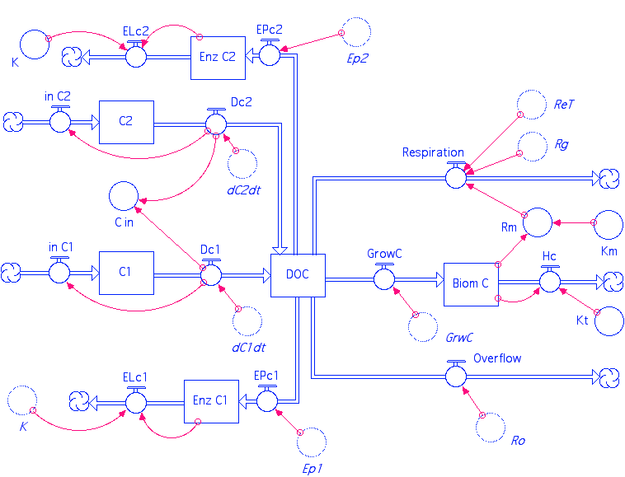

Biom_C(t) = Biom_C(t - dt) + (GrowC - Hc) * dt
INIT Biom_C = 1 { microbial biomass mg C }
INFLOWS:
GrowC = GrwC { C input for microbial growth }
OUTFLOWS:
Hc = Kt*Biom_C { Microbial death/turnover; fixed proportion/d }
C1(t) = C1(t - dt) + (in_C1 - Dc1) * dt
INIT C1 = 500 { mg soil organic carbon pool 1; this substrate has N }
INFLOWS:
in_C1 = Dc1 { at steady state, inputs equal outputs }
OUTFLOWS:
Dc1 = dC1dt
C2(t) = C2(t - dt) + (in_C2 - Dc2) * dt
INIT C2 = 1000-C1 { mg soil organic carbon pool 2; this substrate has no N }
INFLOWS:
in_C2 = Dc2 { at steady state, inputs equal outputs}
OUTFLOWS:
Dc2 = dC2dt
DOC(t) = DOC(t - dt) + (Dc1 + Dc2 - GrowC - EPc1 - EPc2 - Respiration - Overflow) * dt
INIT DOC = 0 { solubilized-dissolved organic carbon }
INFLOWS:
Dc1 = dC1dt
Dc2 = dC2dt
OUTFLOWS:
GrowC = GrwC { C input for microbial growth }
EPc1 = Ep1 { amount of C used in enzyme 1 production }
EPc2 = Ep2 { amount of C used in enzyme 2 production }
Respiration = Rg+ReT+Rm { C flux for growth respiration and overflow metabolism }
Overflow = Ro
Enz_C1(t) = Enz_C1(t - dt) + (EPc1 - ELc1) * dt
INIT Enz_C1 = { Initial enzyme 1 pool } 0.02*Biom_C
INFLOWS:
EPc1 = Ep1 { amount of C used in enzyme 1 production }
OUTFLOWS:
ELc1 = K*Enz_C1 {{ enzyme 2 turnover; fixed proportion/d }
Enz_C2(t) = Enz_C2(t - dt) + (EPc2 - ELc2) * dt
INIT Enz_C2 = 0.02*Biom_C { Exoenzyme C2 pool }
INFLOWS:
EPc2 = Ep2 { amount of C used in enzyme 2 production }
OUTFLOWS:
ELc2 = K*Enz_C2 { enzyme 2 turnover; fixed proportion/d }
C_in = Dc1+Dc2
K = 0.05 { enzyme turnover coefficient/d }
Km = 0.01 { microbial maintenance respiration coefficient/d }
Kt = 0.012 { microbial biomass turnover coefficient/d }
Rm = Km*Biom_C { maintenance respiration }

Sector 02 Enzyme allocation

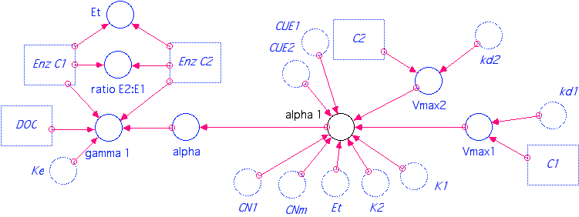

alpha = alpha_1
alpha_1 = max(0,min(1, 1/2*(CN1*Vmax1*CUE1*K2+Et*CN1*Vmax1*CUE1+Et*CN1*Vmax2*CUE2-CN1*Vmax2*CUE2*K1-CNm*K2*Vmax1-CNm*Vmax1*Et+(-2*CNm*Vmax1*Et*CN1*Vmax2*CUE2*K1+2*Et*CN1^2*Vmax1*CUE1*Vmax2*CUE2*K1+2*CNm*K2*Vmax1*CN1*Vmax2*CUE2*K1-2*CNm*K2*Vmax1*Et*CN1*Vmax2*CUE2-2*CN1^2*Vmax1*CUE1*K2*Vmax2*CUE2*K1+2*CN1^2*Vmax1*CUE1*K2*Et*Vmax2*CUE2-4*CNm*Vmax1^2*Et*CN1*CUE1*K2-2*CNm*Vmax1*Et^2*CN1*Vmax2*CUE2+2*Et^2*CN1^2*Vmax1*CUE1*Vmax2*CUE2+CNm^2*Vmax1^2*Et^2+CNm^2*K2^2*Vmax1^2+2*Et*CN1^2*Vmax1^2*CUE1^2*K2-2*CNm*K2^2*Vmax1^2*CN1*CUE1+2*CN1^2*Vmax2^2*CUE2^2*K1*Et-2*CNm*Vmax1^2*Et^2*CN1*CUE1+2*CNm^2*Vmax1^2*Et*K2+Et^2*CN1^2*Vmax1^2*CUE1^2+CN1^2*Vmax1^2*CUE1^2*K2^2+CN1^2*Vmax2^2*CUE2^2*K1^2+Et^2*CN1^2*Vmax2^2*CUE2^2)^(1/2))/Et/(CN1*Vmax1*CUE1+CN1*Vmax2*CUE2-CNm*Vmax1) ))
Et = Enz_C1+Enz_C2 { calculate the total enzyme pool size }
gamma_1 = if DOC>0 then max(0,min(1,(-Enz_C1 + alpha*Enz_C1 + alpha*Enz_C2 + alpha*Ke*DOC)/(Ke*DOC))) else 0 { fraction of total enzyme PRODUCTION allocated to Enz_1 }
ratio_E2:E1 = Enz_C2/Enz_C1
Vmax1 = kd1*C1 { maximum rate of SOC1 decay }
Vmax2 = kd2*C2 { maximum rate of SOC2 decay }

Sector 03 Enzyme C production and respiration

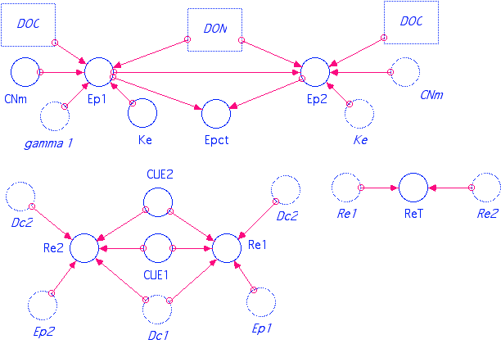

CNm = 7.16 {Microbial C:N ratio}
CUE1 = 0.5
CUE2 = 0.5 { Place right hand side of equation here... }
Ep1 = min(Ke*DOC,CNm*DON)*gamma_1 { enzyme 1 production; limited by C and N }
Ep2 = min(Ke*DOC,CNm*DON)-Ep1 { enzyme 2 production; limited by C and N }
Epct = Ep1+Ep2 { total amount of C used for enzyme 1+2 production }
Ke = 0.05 { Fraction of C-uptake allocated to exoenzyme production }
Re1 = Ep1*((1-CUE1)/CUE1*Dc1/(Dc1+Dc2) + (1-CUE2)/CUE2*Dc2/(Dc1+Dc2)) { Respiratory cost of enzyme 1 production }
Re2 = Ep2*((1-CUE1)/CUE1*Dc1/(Dc1+Dc2) + (1-CUE2)/CUE2*Dc2/(Dc1+Dc2)) { Respiratory cost of enzyme 2 production }
ReT = Re1+Re2 { total respiration for enzyme production }

Sector 04 Decay rates

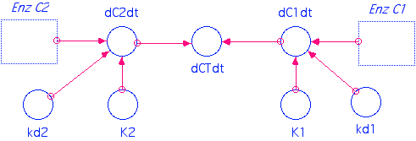

dC1dt = kd1*Enz_C1/(K1 + Enz_C1) { SOC1 solubilization by enzyme action }
dC2dt = kd2*Enz_C2/(K2 + Enz_C2) { SOC2 solubilization by enzyme action }
dCTdt = dC1dt+dC2dt
K1 = 0.3 { enzyme activity half-saturation constant }
K2 = 0.3 { Place right hand side of equation here... }
kd1 = 1 { Place right hand side of equation here... }
kd2 = 1.0 { Place right hand side of equation here... }

Sector 05 Nitrogen flow routine

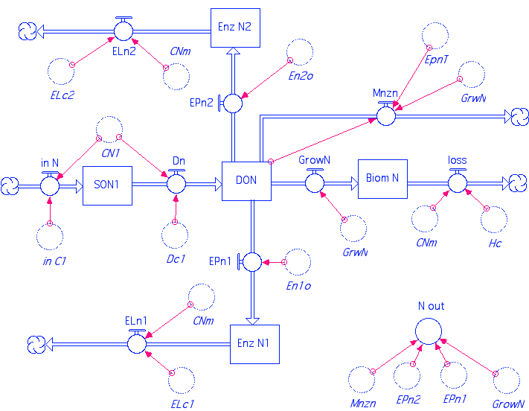

Biom_N(t) = Biom_N(t - dt) + (GrowN - loss) * dt
INIT Biom_N = Biom_C/CNm { microbial N content }
INFLOWS:
GrowN = GrwN { DON uptake into microbial biomass }
OUTFLOWS:
loss = Hc/CNm {Death/turnover N}
DON(t) = DON(t - dt) + (Dn - GrowN - EPn1 - EPn2 - Mnzn) * dt
INIT DON = 0 { solublized-dissolved organic N }
INFLOWS:
Dn = Dc1/CN1 { SON solubilization }
OUTFLOWS:
GrowN = GrwN { DON uptake into microbial biomass }
EPn1 = En1o { amount of DON used in enzyme 1 production }
EPn2 = En2o { amount of DON used in enzyme 2 production }
Mnzn = DON-GrwN-EpnT
Enz_N1(t) = Enz_N1(t - dt) + (EPn1 - ELn1) * dt
INIT Enz_N1 = Enz_C1/CNm { initial N content of enzyme 1 }
INFLOWS:
EPn1 = En1o { amount of DON used in enzyme 1 production }
OUTFLOWS:
ELn1 = ELc1/CNm { Exoenzyme 1 turnover N }
Enz_N2(t) = Enz_N2(t - dt) + (EPn2 - ELn2) * dt
INIT Enz_N2 = Enz_C2/CNm { initial N content of enzyme 2 }
INFLOWS:
EPn2 = En2o { amount of DON used in enzyme 2 production }
OUTFLOWS:
ELn2 = ELc2/CNm { Exoenzyme 1 turnover N }
SON1(t) = SON1(t - dt) + (in_N - Dn) * dt
INIT SON1 = C1/CN1 { N content of soluble organic carbon pool 1 }
INFLOWS:
in_N = in_C1/CN1 { Inputs of organic N }
OUTFLOWS:
Dn = Dc1/CN1 { SON solubilization }
N_out = EPn1+EPn2+GrowN+Mnzn

Sector 06 Microbial growth & respiration

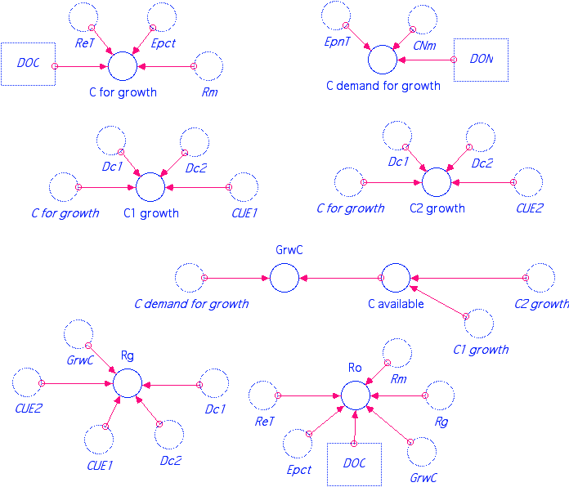

C1_growth = C_for_growth*CUE1*Dc1/(Dc1+Dc2) { growth from SOC1-C }
C2_growth = C_for_growth*CUE2*Dc2/(Dc1+Dc2) { growth from SOC2-C }
C_available = C1_growth+C2_growth { total C available for growth }
C_demand_for_growth = max(0,(DON-EpnT)*CNm) { C demand given N availability }
C_for_growth = max(0,DOC-Rm-Epct-ReT) { DOC left after enzyme production and maintenance }
GrwC = max(0 , min( C_available , C_demand_for_growth )) { microbial growth C }
Rg = GrwC*((1-CUE1)/CUE1*Dc1/(Dc1+Dc2) + (1-CUE2)/CUE2*Dc2/(Dc1+Dc2)) { Respiratory cost of microbial growth }
Ro = max(0,DOC-(Epct+GrwC+ReT+Rg+Rm)) { overflow metabolism }

Sector 07 Enzyme N production and N immobilization

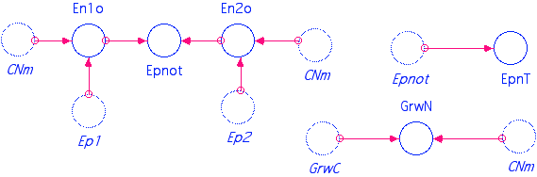

En1o = Ep1/CNm { DON immobilized in enzyme 1 production }
En2o = Ep2/CNm { DON immobilized in enzyme 2 production }
Epnot = En1o+En2o { total DON immobilized by production of enzymes 1+2 }
EpnT = Epnot { total N immobilization in enzymes production }
GrwN = GrwC/CNm { DON used for biomass production }

Sector 09 CN ratios; Given and estimated

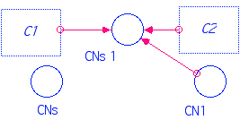

CN1 = 5
CNs = 25
CNs_1 = CN1*(C2+C1)/C1 { C:N ratio of total litter substrate }

