LCImod (Ligno-cellulose) model diagrams and code

TITLE:
Calculating co-metabolic costs of lignin decay and their impacts on carbon use efficiency

AUTHORS:
Daryl L. Moorhead
Dept. of Environmental Sciences
University of Toledo
2801 W. Bancroft St.
Mail Stop 604
Toledo, OH 43606
(419) 530-2017
http://www.utoledo.edu/nsm/envsciences/faculty/moorhead.html

Gwenaëlle Lashermes
Institut National de la Recherche Agronomique
UMR614 Fractionnement des AgroRessources et Environnement
F-51100 Reims, France

Robert L. Sinsabaugh
Dept. of Biology
University of New Mexico
167A Castetter Hall
Albuquerque, NM 87131
(505) 277-3407
http://biology.unm.edu/sinsabaugh/

Michael N. Weintraub
Dept. of Environmental Sciences
University of Toledo
2801 W. Bancroft St.
Mail Stop 604
Toledo, OH 43606
(419) 530-2585
http://www.utoledo.edu/nsm/envsciences/faculty/weintraub.html

FUNDING SOURCE AND GRANT NUMBER:
National Science Foundation, Ecosystem Program
Award # 0918718

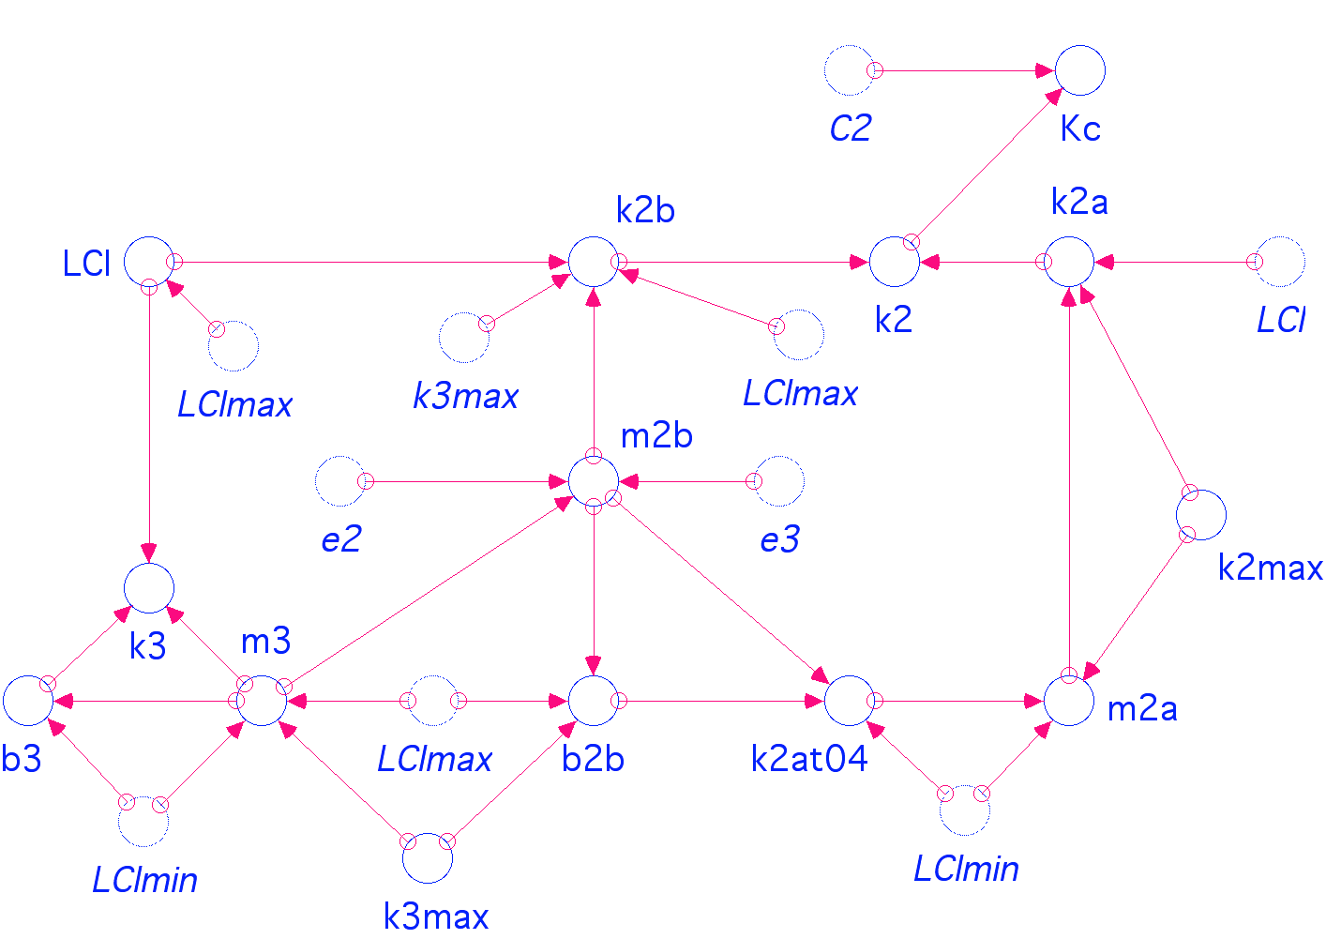

C2 = 200 { Polysaccharide pool size; user specified }
C3 = 100 { Polyphenolics pool size; user specified }
LCI = C3/(C3+C2) { Lignocellulose index }
k2 = max(k2a,k2b) { Realized decay rate coefficient for C2 }
k2max = 0.1 { maximum decay rate coefficient for C2; user specified }
k2a = k2max+m2a*LCI { Decay rate coefficient when LCI < LCI threshold }
m2a = (k2max-k2at04)/(0-LCImin) { Slope of the relationship between k2 and LCI when LCI > LCI threshold }
k2b = m2b*LCI-(m2b*LCImax-k3max) { Decay rate coefficient for k2 when LCI > LCI threshold }
m2b = m3*e2/e3 { Slope of the relationship between k2 and LCI when LCI > LCI threshold }
b2b = k3max-m2b*LCImax { Intercept of the linear relationship between k2 and LCI when LCI > threshold LCI }
k2at04 = m2b*LCImin+b2b { k2 value at LCI threshold }
k3 = max(0,m3*LCI+b3) { Calculated decay rate coefficient for C3 }
b3 = (0-LCImin)*m3 { Intercept of the linear relationship between k3 and LCI }
k3max = 0.01 { Maximum decay rate coefficient for C3 }
m3 = k3max/(LCImax-LCImin) { Slope of the relationship between k3 and LCI }
Kc2 = C2/k2-C2 { Half-saturation coefficient for C2 }

