Oceanography Writing Exercise After the First Exam Spring 2011
Each answer is worth 12 points (25 points total).

This Exercise:
The point of this exercise is to give you practice organizing and writing clear, concise answers to test questions.

Before starting with this exercise read the attached page with Suggestions for Better Written Answers.

Important: Read everything on these pages. There are lots of tips to help you with the exercise.

Also important: If I wrote “Writing Center” on the your exam, you must have your initial draft of the answers to these questions reviewed by someone in the Writing Center (1st floor Carlson Library). Have them sign the draft, and turn in both the draft and the revised answers.

Answer the two questions from the exam that are attached on the following page. I have added information to each question, that is, these are not exactly the same questions as on the exam.

In each case, answer the specific question without adding extraneous information. Be clear and to the point with your explanations. Use an effective sketch when that would help explain the setting or process.

Key suggestions in general :
Read the section in the textbook and review the class notes that discuss the concepts presented in each question.
Outline your answer. Create a logical “flow” for the information that you organize into your answer.
Be concise and to the point. Do not write more than one typed page, single spaced, to answer each question. And whatever you do, do NOT cut & paste or copy out of the book.
Set aside what you just wrote. Later, re-read it. Is it clear? Does it make sense? If you gave this explanation to someone not taking this course, would he or she understand the idea?
Edit your text for spelling, grammar, clarity, and answering the specific question.

Key suggestions specifically for Question 3 :
Read all of Chapter 2 in the textbook, and make sure you understand the concepts.
Talk through the whole idea with a classmate or knowledgeable friend. (Being able to explain the concept orally helps you work through what you do and do not understand about the topic.)
Refer to the figures in the book. Use those images as a foundation for explaining the process.
Refer to my PowerPoint presentation and text notes that are posted on the course website.
Again, be concise and to the point. Do not write more than 1½ typed pages, single spaced, to answer this question.
As with the first question, set it aside, then re-read it and go through the editing process.

The questions from the exam: {Write a well organized and clear answer to each question. }

3. (a) Describe the steps involved in producing a new solar system, with a planets orbiting a central star, from a cloud of gas and dust floating in space.

As part of your answer, explain how the materials that form planets are created then distributed through space, only to be brought back together to produce a new solar system.

{ Make sure you explain supernova, nebula, protoplanetary disk, accretion, and planetesimal in your answer. }

(b) Then explain the processes associated with the differentiation of newly formed planet Earth and the formation of internal layers.

10 (a). One recent technological advance in studying the internal structure and processes of the Earth is mantle tomography, which is similar in concept to a medical CAT scan of your body. Explain how geophysicists (geologists who study the physics of the Earth) use variations in seismic velocity to map the Earth’s mantle in three dimensions. First step: Explain specifically what the relationship is between seismic velocity, rock density, and temperature.

(b). What evidence can geophysicists “see” to support the concept of mantle convection? { That is, explain what processes associated with plate tectonics are shown in the figures. }

{ Use the attached color figures to answer this question. Refer to figure numbers in your answer. }

IMPORTANT:
Refer to the Figure numbers when writing your explanation.

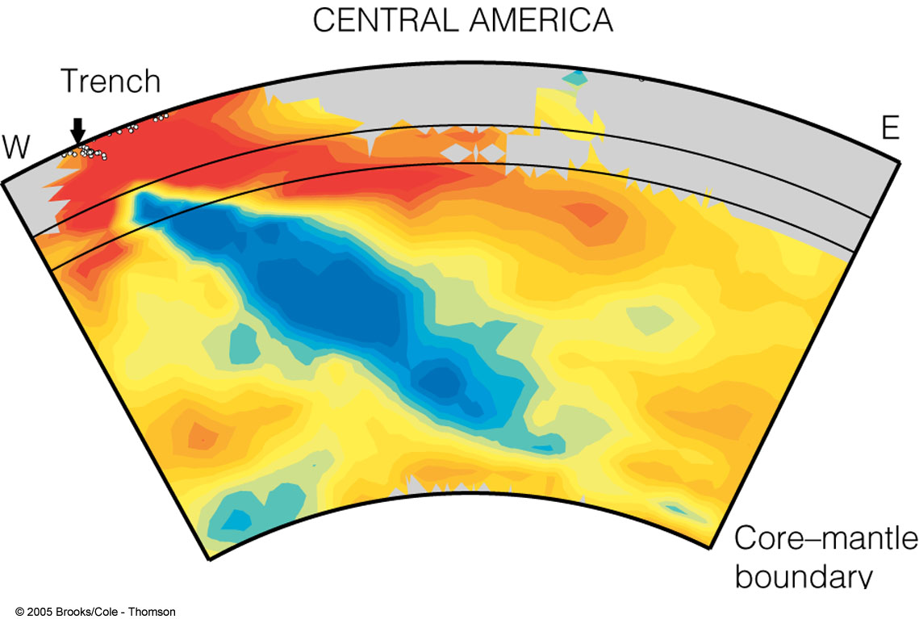
Figure 1. Vertical slice through the mantle. This is figure 3.24 from the textbook.

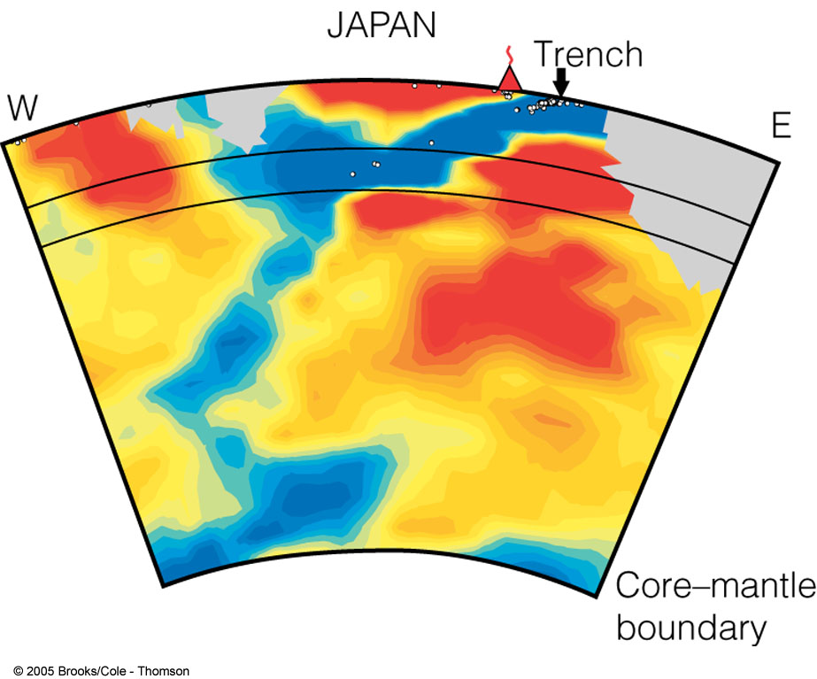
Figure 2. Vertical slice through the mantle. This is figure 3.24 from the textbook.

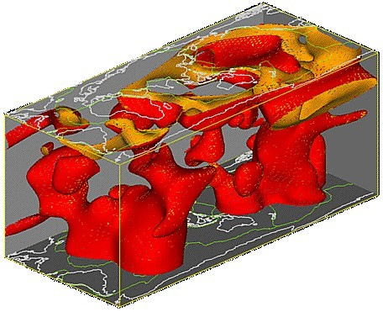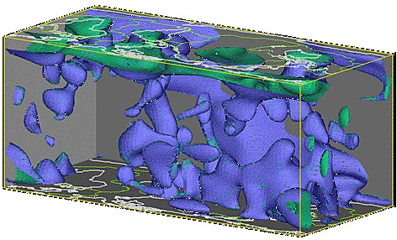

Figure 3. Mantle plumes. Figure 4. Mantle slabs.

