Oceanography Exercise 4
OCEAN BASINS AND PLATE TECTONICS

Many of these questions are similar to those in the textbook at the end of Chapter 3, on page 95 (5th Edition p. 86). The Chapter in Perspective on pages 93-95 is a good review of concepts before you start on this exercise. More information is in Chapter 4.

Short written answers
(a short paragraph with the appropriate information, explained clearly, should be sufficient)

1. Distinguish between the concepts of continental drift, sea-floor spreading, and plate tectonics.

2. How can measurements of layered basalt flows in a volcano on land be used to help determine the age of the ocean floor in the middle of the South Atlantic Ocean?

What two key pieces of information would a geologist have to collect or measure?

Asking the question a different way: If you are studying a volcano that has 2 million years of layered lava flows, what two pieces of information can you obtain from each layer of lava that would help create a paleomagnetic time scale?

3. Draw a map view and a vertical cross section of a mid-ocean ridge with two segments that are offset laterally by a transform fault. On your figure, show the direction of plate motion for each segment of the ridge. Explain the difference between a transform fault and a fracture zone. (Refer to Fig. 4.24, and the Active Figures link on the textbook website.)

Calculations

4. A survey ship with a recording fathometer and a magnetometer is sailing east to west across a segment of the Mid-Atlantic Ridge that runs north to south. (Refer to Figure 3.28 on page 77.) The ship crosses over a series of magnetic highs and lows (as measured by the magnetometer). A strong, broad magnetic high is positioned directly over the ridge crest. It is followed to the west by a magnetic low of modest width and, at 50 kilometers from the ridge crest, a narrow but prominent magnetic high.

Determine the age of this narrow magnetic high by consulting the paleomagnetic timescale shown below. What is the name of the polarity event that you are correlating with the narrow magnetic anomaly on the seafloor?

Determine the spreading rate in centimeters per year for this mid-ocean ridge. (Spreading rates are usually calculated for only one side of a ridge. This is sometimes called a “half-spreading rate”, just to make it clear what is meant.)

Paleomagnetic timescale to use with Question 4:

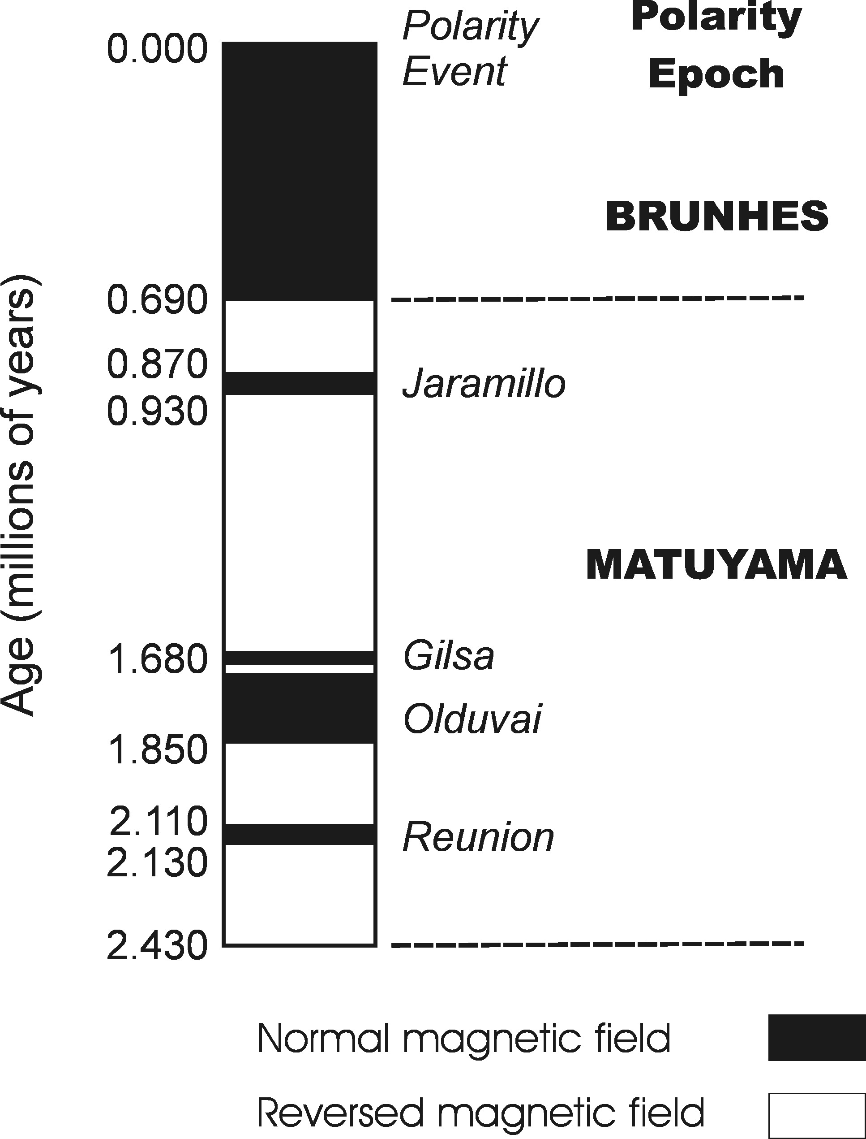

5. Using the spreading rate that you calculated in question 3 above, how much new oceanic crust will be produced by this ridge segment in 1 million years? (Expressed as a linear distance, in kilometers, measured from the axis of the ridge.)

Before you start, the slowest modern spreading rates (Southwest Indian Ridge) are about 1 cm per year, and the fastest (East Pacific Rise) are 6-7 cm per year. If your calculated spreading rate for the North Atlantic is not between these values, go back and check your calculations.

How much oceanic crust will be produced in 50 million years?

If the North Atlantic Ocean is approximately 3,000 miles wide, how old might it be?

First step, convert 3,000 miles to kilometers.

Second step, remember that we have been calculating “half-spreading rates” on only one side of the ridge.

Third step, if this calculated spreading rate is not the same as what you calculated for Question 4, does it make sense? (Would the rate of spreading necessarily be constant for the entire time that an ocean basin is forming?)

Critical-Thinking Essays
(explain in more detail than for the Short Written Answers; but these do not require many pages of explanation)

6. Where in the world ocean is the oldest oceanic crust found? Why is it there?
Is it likely that any oceanic crust older than about 200 million years can be found in any ocean basin? (Explain why or why not.)

The two key figures to look at in the book are Fig. 3.15 on p. 74 (p. 68 in 5th Ed.), which shows the direction of plate motion and the relative width of the plates, and Fig. 3.29 on p. 86 (p. 78 in 5th Ed.), which shows the age of the oceanic crust.

7. Explain how the East African Rift Valley, the Red Sea, and the Atlantic Ocean can be used as a model for the formation of an ocean basin. Refer to Figs. 3.17-18, p. 76 (p.70, 5th Ed. ).

For each step in the evolution of an ocean basin (up to the Atlantic Ocean), give a description of the geographic / geologic setting, and explain the important processes that are occurring.

{ For this exercise, you do not need to explain the closing of an ocean basin, but be familiar with the next steps in the evolution of an ocean basin, which are represented by the Pacific Ocean, Mediterranean Sea, Persian Gulf, and Himalayas / Tibetan Plateau. }

