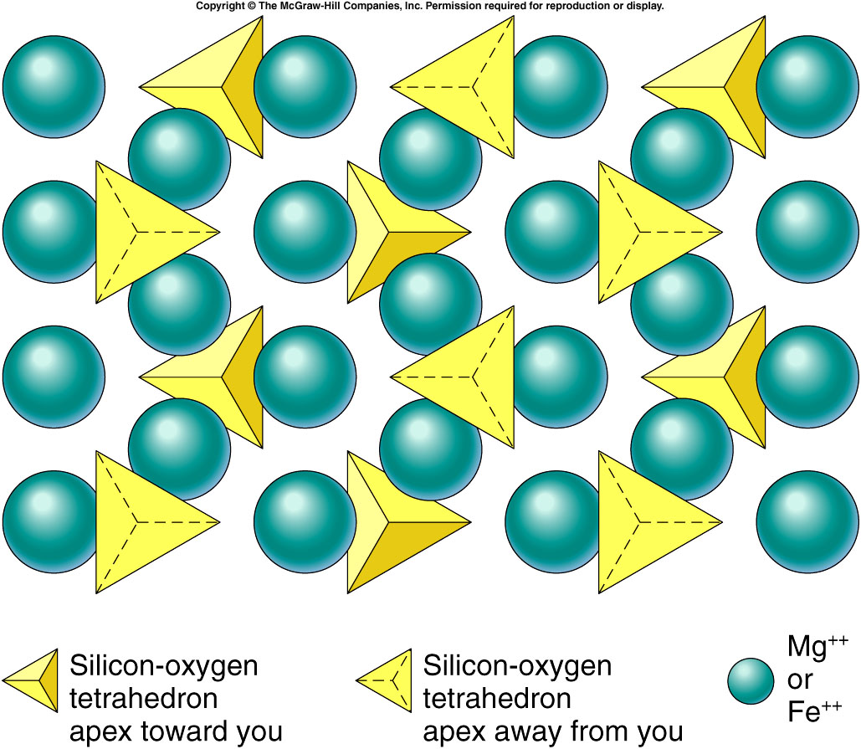

Systematic Classification of Silicate Minerals
Dr. James Martin-Hayden, EEES-1010  Silicate Structure | Example Mineral | Silica Content  (%SiO₂) | Fe/Mg‡ Content | Al† content | Cleavage  Hardness | Density  Color | Occurrence
Isolated  Silicates | Olivine | ~16% | ‡  ~50% | 0% | none  6½ | ~4 g/cm³  green | Comprises most of the Mantle  Isolated Silicates
Single Chain  Single Chain Silicates  Silicates | Pyroxene# Group (e.g., Augite) | 25-50% | ‡  18-26% | (†)  0-16% | 2 (90º)  5½ | ~3.3  black | Found in basalt  Oceanic Curst  with Ca-Plag.#
Double Chain  Silicates | Amphibole◊ Group (e.g., Hornblende) | 50-60% | ‡  15-22% | †  0-9% | 2 (120º-60º)  5½ | ~3.3  black | Found in Continental Crust◊
Sheet  Silicates | Mica Group  (e.g., Biotite◊)  (e.g., Muscovite◊) | 39%  39% | ‡  18-33%  0% | †  6%  20% | 1 (perfect)  2½ | ~3.0  black  2.8 slvr | Found in Continental Crust◊
Double Chain Silicates | Clay Group  (e.g., Kaolinite) | 46% | 0% | †  21% | Microscopic  platelets | 2.6  green  or gray | From chemical weathering of silicates*
Frame-work  Silicates | Feldspar Group,  Plagioclase(Na◊-Ca#)  Orthoclase (K◊) | 43-69%  76% | 0%  0% | †  10-19%  10% † | 2 (90º)  6 | 2.6  wht-blk  2.7 pink | Ca Plag.# in Oceanic Crust  Others Contin◊.
Sheet Silicates | Quartz (pure SiO₂◊) | 100% | 0% | 0% | none (fracture)  7 | 2.6  white to gray | Concentrated in Continental Environments
General trends toward bottom: Increasing SiO₂, Decreasing Fe/Mg, Lighter in density, Lighter in Color
Other Trends
Framework Silicates
- #Oceanic crust (basalt) is mostly pyroxene and Ca-plagioclase (Ca-Feldspar) and thus more dense and dark.
- ◊Continental crust (e.g., granite) contains minerals rich in silica, low in iron, and thus less dense and light in color.
- Melting points (and crystallization temperature) decrease toward bottom.
(e.g., quartz melts first and is the last to crystallize, ~700ºC. Pyroxene and Ca-plagioclase ~1000ºC)
- Rate of chemical weathering decreases toward bottom of the chart or
‡Ferromagnesians
†Alluminosilicates
Chemical Weathering
- Resistance to chemical weathering increases toward bottom.
(e.g., quartz is extremely resistant to chemical weathering)
- *All silicates (except quartz) are converted to clay minerals by chemical weathering.

