EEES 2160 BIODIVERSITY

LABORATORY MANUAL

Fall Semester 2004

Department of Earth, Ecological and Environmental Sciences
University of Toledo

Faculty Coordinator:
Dr. Daryl Dwyer

Acknowledgments

Gratitude is extended to the following graduate students who compiled, wrote and edited this manual: Marcy Gallo, Fafeng Li, Mandy Comes, Jim LeMoine, and Roberta Veluci

Tonya McCarley for providing CD-ROM with digital illustrations from Campbell, N. A., Reece, J. B., and Mitchell, L.G. 1999. Biology. Fifth Edition. Benjamin Cummings ISBN: 0-8053-6566-4.

Rob Gendron (Indiana University of Pennsylvania, Biology Department, Indiana, PA 15705), rgendron@grove.iup.edu, http://www.iup.edu/~rgendron
- Simulating Natural Selection (Week 11)
- Systematics and Phylogenetics (Week 13)

Christine Minor – Clemson University, South Carolina
- Hypothesis Testing (Week 5)

www.labbench.com: pill bug experiment
http://mail.fkchs.sad27.k12.me.us/fkchs/vpig/: fetal pig dissection
http://www.whitman.edu/offices_departments/biology/vpd/main.html: fetal pig dissection

Dr. Deborah Neher for serving as the faculty coordinator of the development of this manual.

Dr. Daryl Moorhead for ideas on format and approach of this laboratory course

Christian Lauber for development of Bacteria Around Us (Week 2)

Dr. Daryl Dwyer and Andrew Hosken for reviews of an earlier draft
Table of Contents

Acknowledgements 1

Safety In The Laboratory 3
Week 1. Microscope and Cell Cycle 4
Week 2. Hypothesis Testing 14
Week 3. Systematics and Phylogenetics 16
Week 4. Population Genetics 24
Week 5. Bacteria around us 27
Week 6. Protista 33
Week 7. Survey of the Kingdom Fungi 39
Week 8. Plant Evolution 43
Week 9. Plant Physiology 49
Week 10. Invertebrates 53
Week 11. Vertebrates: Fetal Pig Dissection 56
Week 12. Simulating Natural Selection 65
Week 13. Human Demography 76

Safety in the laboratory

The exercises in this laboratory were designed with safety as a top priority; you must always follow these safety precautions:
- Wash your hands thoroughly with soap and water when you enter the lab.
- Wear closed-toe shoes. No open-toed shoes or sandals permitted.
- Do not eat, drink, smoke, or apply cosmetics when in lab.
- Use the equipment properly. If you have any questions or problems, contact your instructor.
- Clean up spills or broken glass immediately. Report these to your instructor. Broken glass should be disposed of in a special ‘glass’ box.
- Immediately report all injuries—no matter how minor—to your instructor.
- Keep open flames away from flammable materials including you, clothing, and long hair.
- Never taste any substance or solution. Do not put anything in lab into your mouth.
- Treat all live animals gently and with respect.
- Wear gloves when handling preserved specimens.
- At the end of the lab, wash your hands thoroughly if you have contacted any chemicals.
- Clean and put the microscope away.
- Return all equipment and supplies to their original locations.
- Locate the closest fire extinguisher, fire alarm, eyewash, and other emergency equipment. Familiarize yourself with how to use this equipment.
Week 1

MICROSCOPE AND CELL CYCLE

Preparation: Bring your dissecting kit and textbook to class.

Objectives:
- Identify the parts of a compound microscope and a stereomicroscope and become proficient in their correct use in biological studies.
- Become familiar with the concepts and procedures of mitosis and meiosis and identify different stages of mitosis with the aid of a compound microscope.
- Identify cell structures with a compound microscope.

Introduction:

I. Compound Microscope
Biologists in numerous subdisciplines use microscopes. These subdisciplines include genetics, molecular biology, cell biology, evolution, ecology, and others. The knowledge and the skills you develop today will be used and enhanced throughout this laboratory course and your career in science. It is important, therefore, that you take the time to master these exercises thoroughly. There are many variations of the compound microscope (Fig. 1), but the principles underlying all of these instruments are the same. The microscope consists of a lens system, a controllable light source, and a geared mechanism for focusing the specimen by adjusting the distance between the lens system and the specimen or object observed.
Fig. 1. Olympus CX41 compound microscope.

Lens and magnification
The magnification achieved by a compound microscope is the result of two systems of lenses: the objectives, nearest the specimen, and the ocular, or eyepiece lens, which are at the upper end of the microscope.
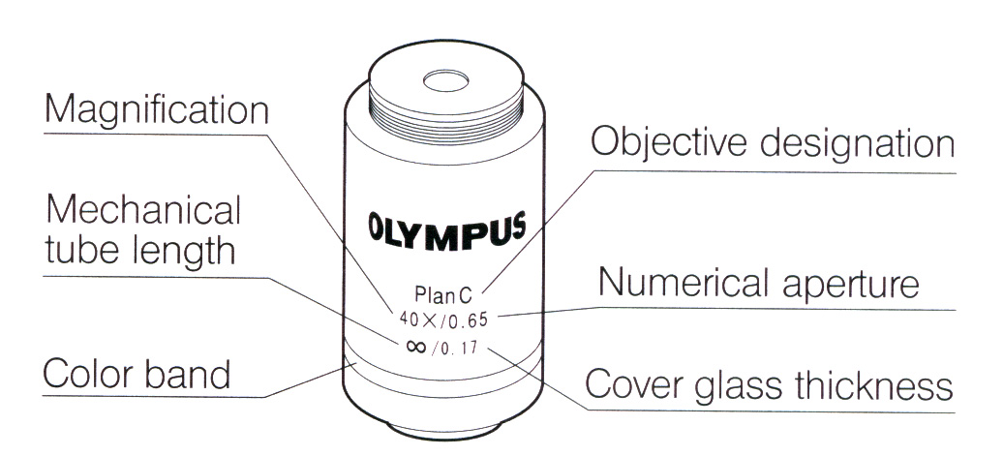
To achieve different degrees of magnification, four objectives are provided on our microscopes. They are attached to a revolving nosepiece. The 10X is the shortest objective and has 10X inscribed on its side to designate its power of magnification. Two high-dry objectives are of intermediate length and will have a magnification of 20X or 40X. The longest objective is the oil immersion objective that will have a magnification of 100X.
Fig. 2. Objective labeling.
To determine the total magnification of a specimen, it is necessary to multiply the magnification of the ocular lens by the magnification of the objective lens. The ocular magnification is inscribed on the top of the eye-lens mount (Fig. 2). If a specimen is viewed with the 40X objective, multiply 40 by 10 to get a total magnification of 400.

Focusing
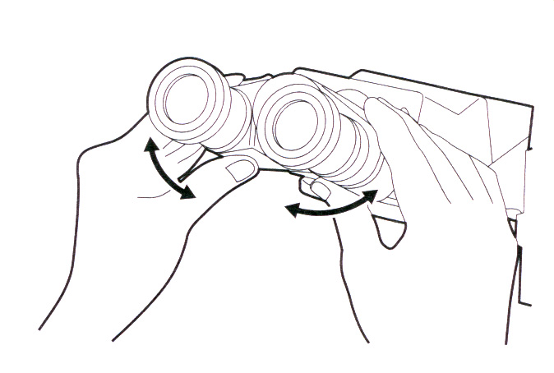
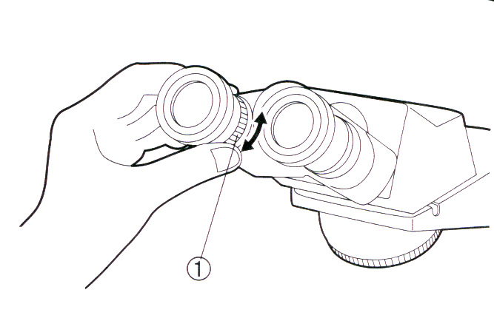
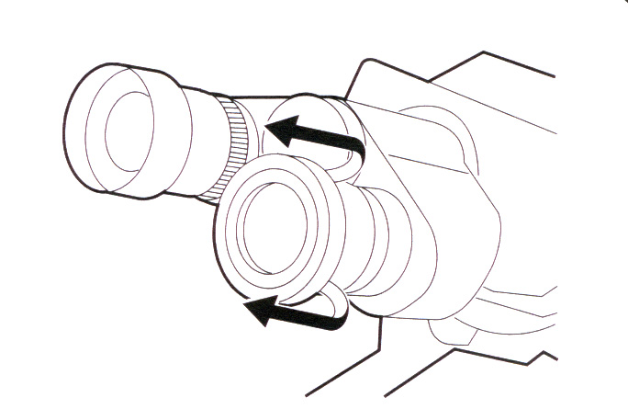
For optimum viewing, adjust the eyepieces by following three steps. First, adjust the interpupillar distance (Fig. 3). While looking through the eyepieces, adjust for binocular vision until the left and right fields of view coincide completely. Record the value associated with the index dot so you can quickly make this adjustment in future labs. Second, adjust the diopter (Fig. 4). Looking through the right eyepiece with your right eye, rotate the coarse and fine adjustment knobs to bring the specimen into focus. Looking through the left eyepiece with your left eye, turn the diopter adjustment ring (1 in Fig. 4) on the specimen. Third, adjust the eyecups. If you wear eyeglasses, use the eyecups in the normal, folded-down position. This will prevent the eyeglasses from contacting and scratching the eyepieces. If you do not wear eyeglasses, extend the folded eyecups in the direction of the arrow (Fig. 5) for efficient use of the eyecups by preventing extraneous light from entering between the eyepieces and eyes.
Fig. 3. Adjusting the interpupillar distance
Fig. 4. Adjusting the diopter.
Fig. 5. Using the eyecups.
To focus the microscope, it is necessary to alter the distance between the slide and objective lens. Knobs on the side of the microscope accomplish this. On most instruments, the objective lens is stationary and the stage moves up and down. Use the coarse adjustment to cover large distances. For critical focusing, the fine adjustment knob is used. Care must be used when using coarse adjustment. Always begin with the lowest power objective in place and bring the stage to the highest position. While looking in the oculars, bring the stage down using coarse adjustment until the object is clear. Never bring the stage toward the objective using coarse adjustment. Slides and lenses can be easily broken if brought into contact.
The working distance of the lens is the distance between the lens and the slide when the specimen is seen in sharp focus.

Illumination
The preferred light source for a microscope is an incandescent bulb because its color,
temperature, and intensity can be controlled and stabilized easily. Condensers consist of two or more lenses that focus light from the illumination source onto a specimen. The light of the condenser is adjustable using a substage knob. Image sharpness is affected considerably by the condenser position (see details in Figs. 6-9). For most work, the condenser will be kept close to the image. The iris diaphragm, located between the condenser and light source, controls the amount of light entering the condenser. If too much light is allowed to illuminate the specimen, image contrast decreases and depth of field is reduced. Excessive illumination may actually burn out the image so that objects become difficult to differentiate. Unstained specimens are best observed with low illumination to increase contrast. Both the 20 X and 40 X objectives will have phase contrast, which provides a means to increase contrast of low-contrast or transparent specimens without use of stains.

Details on Centering and setting the aperture on the iris diaphragm
- Centering the field iris diaphragm (Figs. 6,7)
  - With the 10X objective engaged and the specimen brought into focus, turn the field iris diaphragm ring (1 in Fig. 6) counterclockwise to stop down the diaphragm to near its minimum size
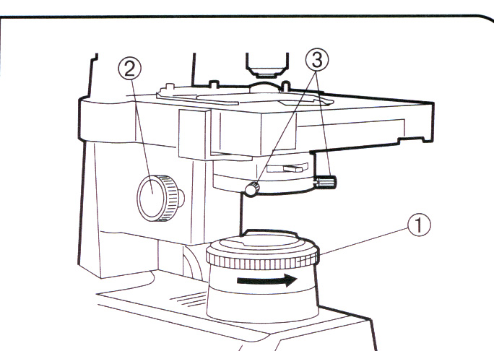
  - Turn the condenser height adjustment knob (2 in Fig. 6) to bring the field iris diaphragm image into focus
Fig. 6.
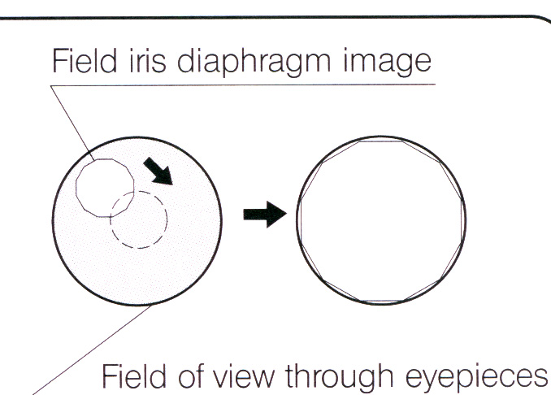
  - Rotate the two auxiliary lens centering knobs (3 in Fig. 6) to adjust so that the field iris diaphragm image is centered in the eyepiece field of view
  - To check centration, open the field iris diaphragm until its image touches the perimeter of the field of view. If the image is not precisely inscribed in the field of view, center again.
  - When used for actual observation, open the field diaphragm until its image is slightly larger than the field of view.
Fig. 7.
- Aperture iris diaphragm (Figs. 8,9)
  - The aperture iris diaphragm determines the numerical aperture (1 in Fig. 9) of the illumination system. Matching the numerical aperture of the illumination system with that of the objective provides better image resolution and contrast, and also increases the depth of focus.
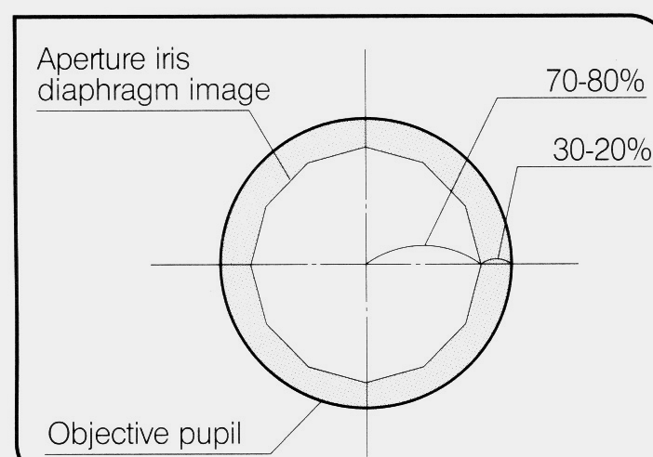
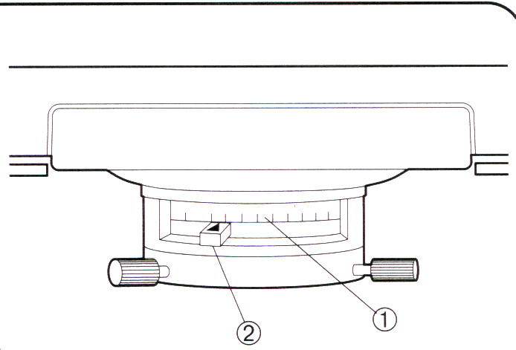
  - Since the contrast of microscope specimens is ordinarily low, setting the condenser aperture iris diaphragm to between 70% and 80% of the N.A. of the objective in use is usually recommended. If necessary, adjust the ratio by removing the eyepieces and looking into the eyepiece sleeves while adjusting the aperture iris diaphragm knob until the image shown in Fig. 8 is seen (Fig. 9). Note: if the aperture iris diaphragm is set too small, image ghost may be observed.
Fig. 8.
Fig. 9.

Use of the microscope for brightfield exposure: Terms listed in bold refer to controls illustrated in Figure 1.
- If moving the microscope is necessary, grip the base firmly with one hand and the arm of the instrument with your other hand. Never pull or push the microscope across the bench. If it needs to be moved, carefully pick it up and move it.
- Check the light source. Set the main switch to “|” (ON) using the Main switch and adjust the brightness with the Light intensity knob. Ask the Instructor for help if you are having problems. Notify the Instructor if the bulb fails to illuminate.
- Check the lens: dust or oil on the lenses may impair your viewing. If the lenses seem to be smeared, please ask the Instructor for help. Improper cleaning can permanently damage the lenses. Use only dry lens tissue. Do not use any other type of paper or cloth. These will scratch the delicate surface of the lens.
- Place the specimen on the stage using the specimen holder and x-axis/y-axis knobs. The specimen side of the slide should be facing up: move the slide until the material to be observed is illuminated by the light source.
- Engage the 10X objective in the light path using the revolving nosepiece. Always begin with the lowest power objective to locate the specimen and then switch to greater magnification.
- Bring the stage toward the objective using the coarse/fine focus adjustment knobs. Beginning with the stage all the way to the top allows you to use the coarse focus knobs to lower the stage until the object is in view. Bring the stage toward the objective without looking can result in damage to the slide or objective.
  - Adjust the interpupillary distance using the binocular tube (Fig. 3)
  - Adjust the diopter with using the diopter adjustment ring and condenser height adjustment knob (Fig. 4)
  - Adjust the light axis with the auxiliary lens centering knob
  - Adjust the aperture iris and field iris diaphragms (Figs. 6-9)
- Engage the desired objective in the light path and bring the specimen in focus using the revolving nosepiece and fine focus adjustment knobs only.
- Switch to higher magnification: use only fine focus with higher power objectives.
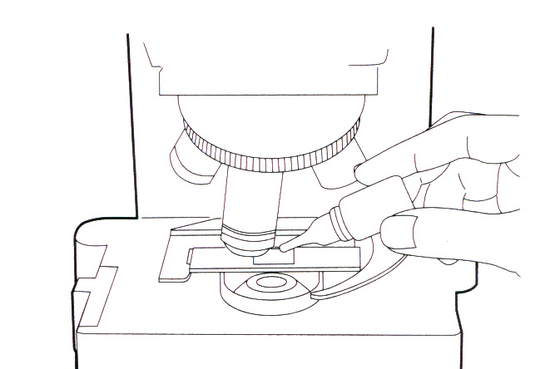
  - Adjust the brightness with the light intensity knob.
- Oil Immersion (Fig. 10):
  - Locate the subject area using the 10X objective
Fig. 10. Using oil immersion objective (100x)
  - Place 1 drop of immersion oil on top of the cover glass
  - Rotate 100 X objective into oil and light path
  - Use fine adjustment knob to focus
  - Adjust condenser diaphragm to ¾ open
  - Adjust light intensity
  - Avoid getting oil on other objectives

Adjustments for Phase Contrast observations
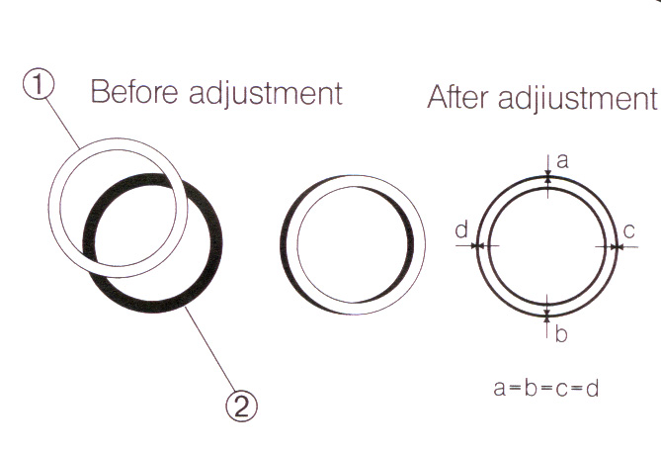
- Turn the revolving nosepiece to engage in light path the phase contrast objective lens with the same value as the ring slit in use. Phase objectives on your microscope are the 10x and 40x objectives.
- Place the specimen and bring it in approximate focus.
- Remove the right eyepiece and replace it with the Centering Telescope (CT).
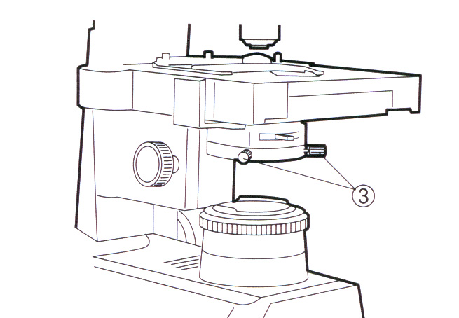
- Turn the upper ring of the CT to adjust the focus so that the bright ring (ring slit, 1 in Fig. 11) and dark ring (2 in Fig. 14) are seen clearly in the field of view (Fig. 14).
Fig. 11.
- Rotate the two centering knobs (3 in Fig. 12) so that the bright and dark rings overlap concentrically. (Figs. 11, 12).
- Remove the CT, replace it with the right eyepiece and start phase contrast observation.
Fig. 12.

II. Stereomicroscope
A stereomicroscope gives you the possibility to look at whole insects, small flowers, and small fossils at magnifications from 6.3 to 30X, without any preparation (do not confuse it with a binocular microscope). Such a stereomicroscope is sufficient for a lot of purposes. And later on, when you feel the need for higher magnifications, a stereomicroscope is very valuable for preparing and sorting of specimens.

Follow these steps for proper use of a stereomicroscope:
- Carefully put your eyes against the eyepieces and push the eyepiece tubes together or apart until with both eyes you can see a single shadow-free circular field. If you wear eyeglasses, fold-down the eyecups to provide the proper viewing distance and protect your eyeglass lenses against scratching.
- To focus the stereomicroscopes, raise or lower it using the focusing drive until the desired object segment is in focus, i.e., inside the objective’s working distance. Initially, select the minimum magnification because it is easier to find the desired object segment in a large field of vision.
- Rotate the magnification changer until the desired magnification is achieved.
- To set parfocality (keep focus constant while adjusting magnification):
  - Position a flat test object beneath the objective.
  - Set the microscope to minimum magnification.
  - Close the eye that is looking into the adjustable eyepiece and look into the fixed eyepiece with the other eye.
  - View the test object and bring into focus with the focusing drive.
  - Without looking into the eyepieces, turn the eyelens of the adjustable eyepiece as far as possible in the “+” direction (counter-clockwise).
  - Close the eye that is looking into the fixed eyepiece and look into the adjustable eyepiece with the other eye.
  - View the test object and slowly turn the eyelens clockwise (in the “-“ direction) until the object is in focus.
  - Set the microscope to maximum magnification.
  - View the test object with both eyes and bring it into sharp focus with the focusing drive.
- Checking parfocality
  - View the object while zooming from minimum to maximum magnification
  - The object would remain in constant focus (parfocal) at all times. If it does not, repeat the procedure for setting parfocality.

Eyepieces with collapsible eyecups for eyeglass wearers
Eyepiece tubes: interpupillary distance adjustable from 55-75mm
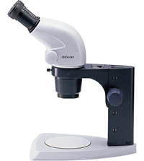

Magnification changer, right-hand pinion knob with magnification scale
Socket for connecting light guide

Focusing drive
Fixing screw

Fig. 13. Leica S4 E stereomicroscope.

Cell cycle
The cell is the fundamental biological unit, the smallest and simplest biological structure possessing all the characteristics of the living condition. Living organisms are composed of one or more cells, and every activity occurring in a living organism is ultimately related to metabolic activities in cells. Thus, understanding the process of life necessitates an understanding of the structure and function of the cell.
A cell’s total hereditary endowment of DNA is called its genome. Although a prokaryotic genome is of a single long DNA molecule, a eukaryotic genome usually consists of several such molecules. Each duplicated chromosome consists of two sister chromatids, the two chromatids contain identical copies of the chromosome. Late in the cell division process, the sister chromatids of all of the chromosomes are pulled apart, and repackaged as complete chromosome sets in two new nuclei, one at each end of the cell. There are two kinds of division methods. In somatic cells and single-celled organisms, the nucleus divides by mitosis into two daughter nuclei, which have the same number of chromosomes and the same genes as the parent cell. Meiosis is used in preparation for sexual reproduction by multi-cellular organisms. In meiosis, nuclei of certain cells in ovaries or testes divide twice but the chromosomes replicate only once. This process results in four daughter nuclei with differing alleles on the chromosomes. By this method, eggs or sperm (or spores in a fungus) are eventually formed.
Events from the beginning of one cell division to the beginning of the next are called a cell cycle. The cell cycle is divided into four phases: G1, S, G2 and M. In this exercise, you will observe dividing cells of onion and distinguish between the divisional stages (Fig. 14).

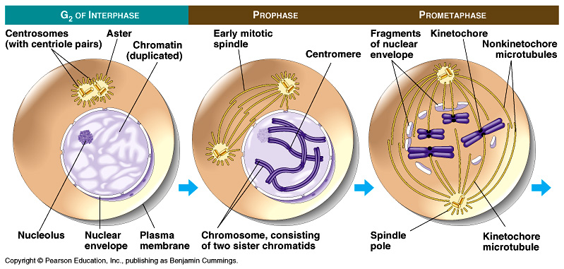

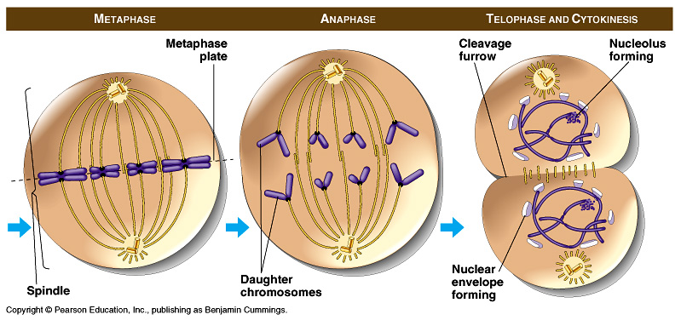
Fig. 14. Divisional stages of Mitosis illustrated for an animal cell.

Materials:

Olympus CX41 compound microscope
Leica S4E stereomicroscope
Dissecting needle
Cover slips
Microscope slides
Onion
Forceps
Stain: methylene blue
Kimwipes
Dropper bottles of distilled water
Commercial slides: comparative onion and animal mitosis
Immersion oil
Lens Paper
Video: Basic Microscope Use and Care

Procedures:
- Watch the informative video tape for Use and Care of the Microscope

Prepare your own slide:
- You will work in pairs
  - 1 member of the pair prepares a stained slide
  - The other member prepares a non-stained slide
- Obtain the following materials:
  - Onion peel
  - 2 microscope slides
  - 2 cover slips
  - Dropper bottle of distilled water
  - Stain
- On the peel surface add 1 drop of water for the non-stained slide and 1 drop of the stain for the stained slide (Fig. 15a). Don’t touch the onion peel!
- Use forceps to remove and transfer a single layer of onion peel onto the slide surface with stain and the other with water (Fig. 15b). Obtain the peel from an inner layer of the onion to insure freshness. Be careful not to fold the peel or it will be difficult to make the required observations.
- Gently lower a cover slip over the onion peel (Fig. 15c). Gently press on the cover slip and then remove any remaining liquid around the cover slip by wicking with a kimwipe (Fig. 15d). Do not twist the cover slip.
- Your slides are now ready to be observed under the compound microscope.

a) Put one drop of water or stain on the slide b) Place an object on the slide

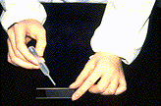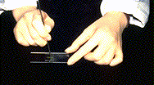
a b
c) Lower the cover slip slowly to avoid air pockets, pull the tweezers out

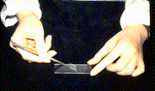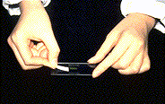
c d

d) After placing the cover slip, the excess water should be absorbed with paper

Figure 15. Preparing a microscope slide

- Using your slide and your partner’s slide:
- Draw and compare stained versus non-stained slides in your notebook.
- Under which magnification were the specimens best observed?
- Obtain an animal (whitefish eggs) and plant (onion tip) slide (commercial slide) from your Instructor. Observe using the oil immersion objective (Fig. 10)
- Make notes of the mitosis phases for animal and plant cell divisions observed on the commercial slide.
- At the end of the lab period:
- Check to make sure lenses, stage and condenser, and commercial slides are clean.
- Clean them gently using lens paper.
- Put the low power objective in place.
11. Put dust cover on
12. Clean your slide thoroughly with lens paper.

Questions: You may want to use your textbook to answer the questions comprehensively.
- What are the structures you saw in your mounted slide?

- Draw the pictures that you have seen on the commercial slide under the microscope and indicate their division stage.

- What are the basic differences between animal and plant cells?

- What is the main difference between mitosis and meiosis?

- Describe the longest phase of the cell cycle.

- What is the shortest part of the cell cycle? What happens during this period?

For extra information on how to use the microscope visit the web site at:
http://www.micro.magnet.fsu.edu/primer/anatomy/anatomy.html. At this site are opportunities to play with virtual microscopy: focusing, magnification and Köhler illumination (http://www.olympusmicro.com/primer/java/kohler/condenseradjust/index.html ).
Week 2

HYPOTHESIS TESTING

Preparation: Bring an inquisitive mind.

Objectives
- Students will make observations and use deductive skills to make inferences and formulate hypotheses.
- Students will use common forensic procedures and other physical evidence to test the formulated hypotheses.

Introduction
The scientific process involves making observations, constructing a hypothesis, which is a suggested explanation that accounts for the observations, and then testing the hypothesis with an experiment. The scientific process calls for the rejection of hypotheses that are inconsistent with experimental results or observations. If a hypothesis is rejected, then it must be revised or a new hypothesis must be formed to account for the results. Hypotheses that are consistent with the results are accepted conditionally; however, the hypothesis is not proven, but only supported by data.
Crime solving has many commonalities with scientific inquiry; both the scientist and detective try to find truth by making inferences, gathering evidence, and testing and revising hypotheses. Evidence may support a hypothesis but, just as in science, the truth may never be found. The more evidence in support of a hypothesis, the more certain we are that it is correct. However, a single piece of evidence may negate a hypothesis and exonerate a suspect. Criminal investigations employ many techniques from the biologist’s arsenal, such as blood typing and DNA analysis. To gain a better understanding of the scientific process and hypothesis testing, we are going to conduct our own murder investigation. Your homework assignment is to write a one-page essay on how our murder investigation compares to the scientific process. Please include specific examples from your inquiry.

Materials:

Suspect Packets
Killer Packet
Blood Type Kit
Crime Scene
Nametags
Scissors (restriction enzyme)

Procedure
- Each student will receive a suspect packet and will take on the role of a person in the storyline. Take your time to read the general information and your specific role.
- Students will form small groups and work as an investigation team.
- Group members will conduct interviews of classmates and pool their information to identify a suspect. The interviewee can be evasive but must answer the questions according to their description of events.
  - Respect yours and others civil liberties. In other words, you are being interrogated and your lawyer’s not present. Don’t be too free to provide information in fear of incriminating yourself.
- Once a suspect is identified, the group will present evidence in support of their allegation to the instructor.
- The instructor will give the group a test to perform or some physical evidence from the scene.
- Once a group has gone through all the evidence and thinks they have solved the murder, they will present their case to the class. If they are correct, the murderer will read their confession. If the group is not correct, the game will continue.

Week 3

SIMULATING NATURAL SELECTION

Preparation: Read this lab exercise carefully before class. Bring your calculator to class.
Objectives:
- Use simulation method to understand the process of natural selection.
- Have a better understanding of how natural selection can result in a change in the genetic makeup of a population.

Materials:
Game Boards
Scissors
Random Numbers Table
White and Yellow Paper

Instructions:
Game boards can be made of poster board which is at least 16” x 16” is size. Using a meter stick, draw 5 columns and 5 rows approximately 3” apart. Label the columns 1-5 across the top. Label the rows down the left side.

Introduction:
We know from the fossil record that species change (evolve) through time. Darwin argued, and this has subsequently been confirmed, that the primary mechanism of evolutionary change is the process of natural selection. Given that evolutionary theory is the most important unifying principle in biology, the importance of understanding natural selection is obvious. The problem is that under most conditions this process is relatively slow, occurring over many generations. Fortunately, by using a simulation, we can study how natural selection works firsthand.
For many years, biologists have used simulations as a tool for understanding ecological and evolutionary processes. These simulations can be extremely complex and require the use of a computer, or they may take the form of relatively simple "games." In this lab, you will play a game that simulates the interaction between a population of predators and its prey over several generations. By the end of the exercise, you should have a better understanding of how natural selection can result in a change in the genetic make-up of a population.

You will recall that several conditions are necessary for natural selection to occur:

- VARIABILITY. Individuals in a population must be different from each other. These differences may involve characteristics such as resistance to cold, susceptibility to disease, photosynthetic efficiency, or the ability to attract a mate, to name just a few.

- HERITABILITY. Some of the variability among individuals must have a genetic basis. Thus, offspring will tend to resemble their parents and have the same traits.

- DIFFERENTIAL REPRODUCTION. Individuals with some traits will leave more descendants than others. This could be either because they survive longer (e.g., faster animals are better at escaping from predators and more likely to reach reproductive age) or because they have a higher reproductive rate (e.g., a bird with more colorful plumage may attract more mates.)

It should be obvious that, given these conditions, certain traits will gradually become more common in the population. In effect, the environment "selects" some traits over others. In this simulation you will look at the evolution of two traits, camouflage in a prey population and visual acuity in predators. Each individual in the populations has a number that indicates the effectiveness of its camouflage (prey) or vision (predator). During the simulation, surviving individuals will periodically reproduce. As in nature, offspring are similar, but not identical, to their parents. In this simulation selection results from differential mortality; prey with poor camouflage are more likely to be killed by predators and predators with low visual acuity are more likely to die of starvation.

I. Playing the Game
The game is played on a board divided into 5 rows and 5 columns. Each animal is represented by a numbered piece of paper indicating an animal's camouflage or visual acuity. Different colored paper will be used for predators and prey. Each round begins by randomly placing the predators and prey on the board. Predators then search for prey within their square and, if successful, reproduce. Predators that have not caught any prey within two rounds starve. Prey that are not captured have the opportunity to reproduce in each round, but only if they are not too crowded.

Each student in a group has a different task. Some of these tasks will have to be combined if there are fewer than four students.

  - The GAME MASTER has the primary responsibility for carefully reading the instructions and ensuring that each step is performed properly and in the correct sequence. If you have any questions, ask your instructor before proceeding. If the instructions are not followed to the letter the simulation will fail and you will have to start over.

  - The RANDOMIZER reads numbers off a random numbers table. These numbers are used when placing animals on the board randomly at the beginning of each round. The use of a random numbers table is analogous to rolling dice. It adds an element of chance to the simulation.

  - The DISTRIBUTOR is in charge of placing and removing pieces from the board. The random numbers read by the second person determine where a particular piece is placed.

  - The RECORDER cuts up and labels additional pieces as they are needed. This person should also record and graph the results as they come in.

SETUP:
You must prepare the game pieces before beginning the simulation. Cut out 1" squares of paper. Use a different color for predators and prey. If you put a bend in them as shown in Figure 1 they will be easier to pick up. You need 16 prey and 16 predators to start and more as the game progresses. Prey varies from easy to detect (a score of 2) to well camouflaged (8). Similarly, the predators vary from 2 to 8 in visual acuity. Label the prey and predator pieces as described in Table 1. The initial frequency distribution of each population is shown in Figure 3 at the end of this exercise. In addition, predator pieces must have a number to indicate when they were born. Put a small 0 on each predator's piece to indicate that it was born in the Setup Round. If these predators have not eaten by the end of Round 2 they will starve.

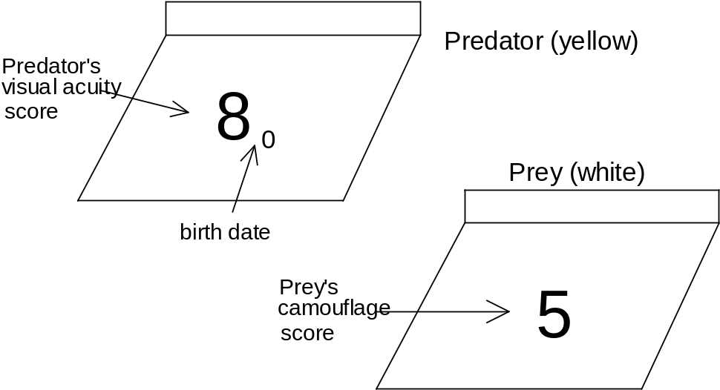
Figure 1. Two game pieces, a prey with a camouflage score of 5 and a predator with a visual acuity score of 8. The predator was born in round 0. If it does not feed in round 1 or 2 it will starve.

Table 1. Initial Frequency Distribution of Traits in Predator and Prey Populations. This shows the number of prey and predators with a particular camouflage score or visual acuity, respectively. See Figure 3 for illustration of a frequency distribution plot.
Camouflage / Vision Score |  | # Prey Pieces | # Predator Pieces
Worst 2 |  | 1 | 1
3 |  | 2 | 2
4 |  | 3 | 3
5 |  | 4 | 4
6 |  | 3 | 3
7 |  | 2 | 2
Best 8 |  | 1 | 1
 | Total # Pieces: | 16 | 16
What is the mean camouflage score of the prey population ? ________

What is the mean visual acuity of the predator population? ________

Keep in mind that these numbers are starting values. After a couple of rounds the scores may be much higher. Scores can go above 8 but they cannot go below 0.

ROUND 1:
Here is where the animals are actually placed on the board and begin to interact with each other. Take your time with this round as you learn the rules of play. Subsequent rounds will go faster. Be sure to ask your instructor if any of the instructions are not clear.

  - DISPERSAL. Use the table of random numbers to put each animal in turn on the board. You can begin anywhere on the table and read numbers from top-to-bottom or left-to-right. Each pair of numbers represents the coordinates of one of the squares on the board. For example, if the number is 25 place the animal in column 2 and row 5.

  - PREDATION. After all animals are placed on the board each predator now has a chance to eat and reproduce, but only if there is a prey in the same square with a camouflage score less than the predator's visual acuity. For example, a predator with a visual acuity of 6 will detect and eat a prey with a camouflage score of 5, but not one with a score of 7. If the predator and prey have the same number flip a coin to see who wins. If the prey wins, it survives but does not reproduce and the predator lives. Remove dead prey immediately. After a predator eats, it then reproduces as described in (c) below.

If there are more than one predator and/or prey on a square these rules apply:

  - If there are two predators the one with the greatest visual acuity will see the prey first and eat it.

  - If there are two prey, the one with the poorest camouflage will be seen and eaten first.

  - A predator can eat only one prey. It then reproduces and dies (see below).

c. PREDATOR REPRODUCTION. When a predator eats, it obtains enough energy to produce two offspring. Then it dies and is removed from the board. Remember that in nature parents and their offspring tend to resemble each other but are not identical. To simulate this, let one of the two offspring have a visual acuity score greater than the parent by 1 (there in no upper limit to visual acuity). Give the second offspring a score that is one less than the parent, but no lower than 0. If there is any uneaten prey remaining in the square, the offspring can immediately eat them (and reproduce themselves) if their visual acuity is high enough. Thus, you could have several generations of predators in one round.

Mark each new offspring with the number of the round in which it was born (in this case round 1). Figure 2 illustrates an example of an interaction (steps b and c) within one square on the board.

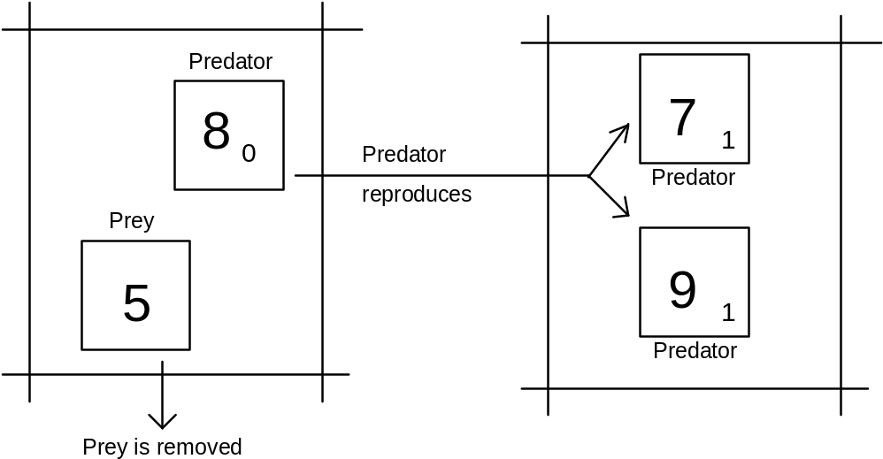
Figure 2. A predator with a visual acuity of 8 eats a prey with a camouflage of 5 and then reproduces and dies.

d. STARVATION. Normally in step (d) predators that had not eaten in two rounds would starve. In Round 1, however, none of the predators have been around long enough so skip this step for now.

e. PREY REPRODUCTION. All surviving prey now have the opportunity to reproduce. However, a prey can reproduce only if no other prey occupy the same square. If two prey occupy the same square there is not enough food to supply the energy needed for reproduction. However, prey do not starve. They survive into the next round. (The presence of predators in the square does not prevent a prey animal from reproducing since predators do not compete for the same food eaten by the prey.)

Reproduction by prey is the same as in predators. Each prey is replaced by two offspring, one of which has better camouflage (by 1) and one of which has worse camouflage (by 1), except that camouflage can never drop below 0.

f. RECORD RESULTS. At the end of each round calculate the mean scores for surviving predators and prey. Record these numbers in Table 2 NOW!

ROUND 2:
Round 2 is similar to Round 1 except now any predators that have not eaten in two rounds will starve.

a. Did you record the mean scores of predators and prey after the previous Round? If so, then remove all the animals from the board and, using the random numbers table, redistribute them as you did before.
b. Predators eat and reproduce if a prey with a lower score occupies their square. Be sure to label new predators with the round in which they were born (2).

c. Predators that have not eaten in two rounds starve and are removed. Since this is Round 2 any predators labeled with a 0 starve. Remove them from the board.

d. Prey reproduce as before.

e. Record the number of predators and prey in Table 2.

ROUNDS 3, 4, and 5:
Repeat the steps of the previous round for as long as time permits, or until one of the populations goes extinct. Remember to remove any predators that have not eaten in two rounds and to mark all new predators with the round in which they were born.

II. Data Analysis

1. Figure 3 shows the initial frequency distribution for each population. Superimpose the final frequency distribution on the same graph.

2. On Figure 4, plot the mean score of each population over time.

3. On Figure 5, plot the size of each population over time.

Questions (Answer in complete sentences):

- Did the mean camouflage and visual acuity increase or decrease? By how much?

- Compare the initial and final frequency distributions in Figure 3. Did the variability of the two populations change? By how much? (Hint: an approximate measure of variability is the range of scores for each population.)

- You probably noticed that there is an element of chance in this simulation. Explain. Give two examples of chance events that might affect the course of evolution in nature.

- If you increased the initial size of each population to 1000 (with a corresponding increase in the size of the board) would this increase or decrease the importance of chance events on the final outcome? Explain.

- Sometimes, during the course of a simulation, a population will go extinct. Explain how the probability of extinction in nature is related to population size.
- Was there any pattern to the changes in the size of the two populations? What would you expect to happen in natural populations?

- Draw graphs to show how the mean score and population size change through time. Each graph should show two lines, one for the predators and one for the prey. See Figure 3 (below) as an example.

Table 2: Record the mean score and number alive at the end of each round. You may complete more or less than 10 rounds depending on time.
 | PREY POPULATION |  | PREDATOR POPULATION
ROUND | Avg. Score | # Alive | Avg. Score | # Alive
0 | 5.0 | 16 | 5.0 | 16
1
2
3
4
5
6
7
8
9
10

Table 3: After the last round record the number of pieces with a particular score for both predators and prey. Plot these numbers on the frequency distribution in Figure 3.

SCORE | # Prey | # Predators
0
1
2
3
4
5
6
7
8
9
10
11
12
13
14
15
16
17
18

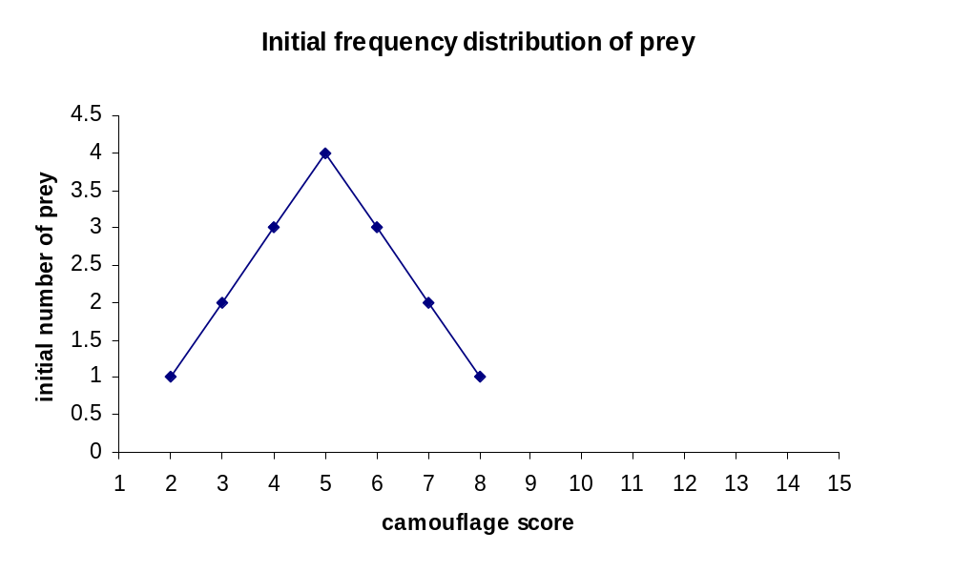

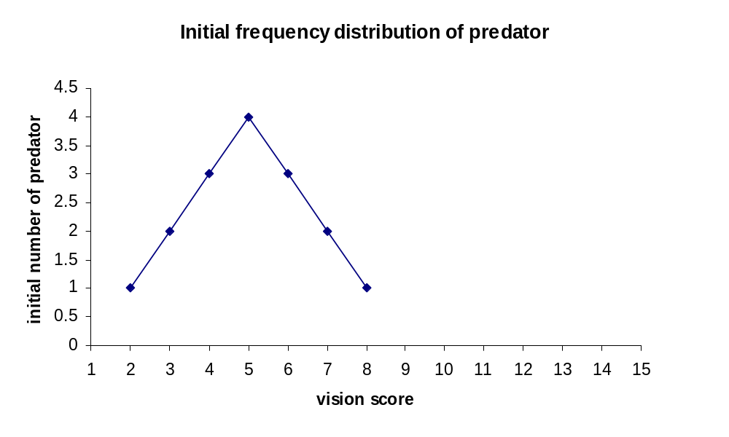

Figure 3. Frequency distributions showing the initial variability in camouflage (prey) and visual acuity (predator). Draw the final frequency distributions on the same graphs for comparison.

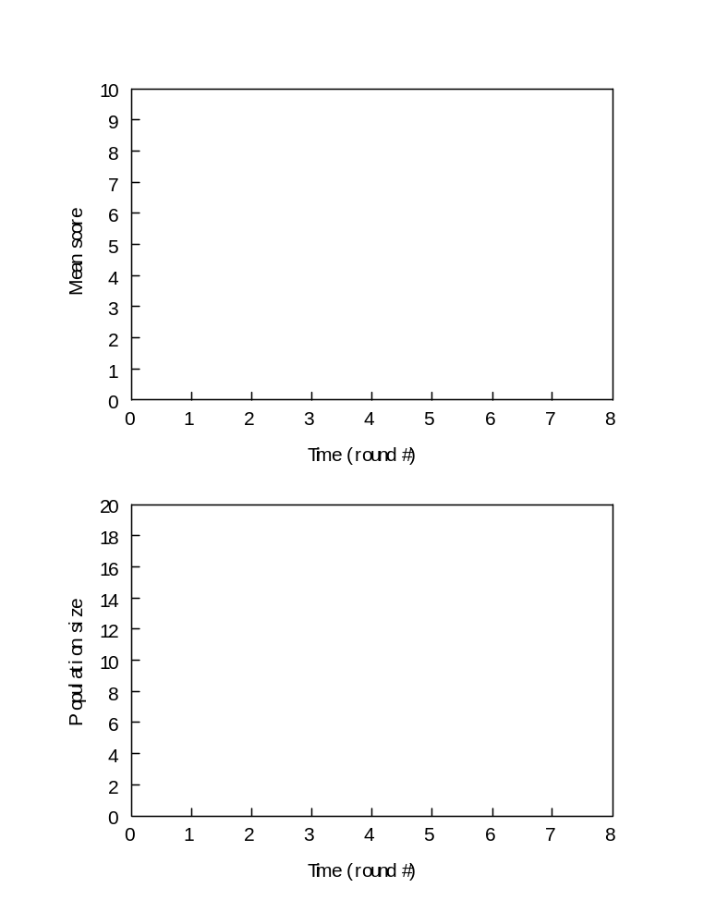
Figures 4 and 5. Draw graphs to show how the mean score and population size change with time. Each graph should show two lines, one for the predators and one for the prey.
Random Numbers from 1-5

3 2 2 5 4 3 1 1 1 3 2 5 2 1 2 4 4 5 2 1 2 3 3 4
5 2 4 3 4 5 3 2 2 2 1 1 4 4 1 1 4 2 5 5 1 4 3 5
4 5 3 5 1 2 2 5 4 3 4 1 4 5 2 3 2 1 4 4 1 5 4 3
2 5 2 3 5 1 3 3 3 1 5 3 3 1 2 3 2 4 1 3 2 1 5 2
4 3 3 3 5 1 3 4 3 3 5 5 2 3 5 3 4 4 1 5 3 3 3 1
1 5 5 4 4 2 1 4 3 2 5 1 3 5 1 4 2 2 4 1 2 2 5 2
4 2 3 3 3 3 4 3 3 1 3 1 1 4 4 4 2 4 5 5 5 3 3 3
4 3 5 1 5 4 3 1 1 3 4 2 1 2 3 3 2 2 4 4 2 2 1 5
3 1 2 2 5 4 4 1 5 4 1 1 2 1 3 2 3 1 5 5 4 4 5 4
2 5 1 5 1 1 1 4 1 1 4 1 3 1 4 4 1 3 5 5 3 1 1 3
2 5 2 3 1 1 2 2 1 3 2 1 2 3 5 4 5 1 4 1 2 4 2 3
5 1 5 3 1 4 4 4 4 2 5 3 4 4 5 1 3 3 3 3 4 3 3 1
2 3 3 1 5 4 1 3 3 5 2 2 2 2 5 4 4 4 1 3 2 3 5 2
3 2 4 2 4 2 2 5 2 3 4 4 3 3 3 3 3 3 4 4 5 2 3 4
1 5 5 1 3 1 3 1 4 3 3 5 5 4 5 2 4 2 5 4 1 2 1 1
1 4 4 2 4 1 3 4 3 1 4 2 3 1 2 3 1 1 3 1 3 1 2 3
4 1 1 4 1 2 1 5 2 5 4 1 3 2 4 1 4 4 1 3 1 5 1 5
1 1 2 5 2 3 5 2 2 5 3 5 3 2 2 1 4 3 5 4 5 1 3 3
1 1 3 3 2 5 1 5 4 2 2 2 4 2 2 1 1 3 1 4 1 4 2 2
2 4 3 4 5 4 1 5 1 4 4 1 2 1 3 4 5 5 5 1 3 4 5 2
2 5 2 5 3 3 4 3 4 1 2 4 4 5 2 4 3 1 3 5 2 3 3 4
5 5 3 1 4 4 4 5 5 3 4 2 1 2 1 2 3 1 5 1 1 1 2 2
2 1 5 3 4 5 4 5 3 1 3 5 5 5 5 3 4 3 1 3 2 4 4 3
1 5 5 2 3 2 3 4 5 3 4 3 3 5 2 2 1 3 4 2 4 3 2 3
4 4 1 1 3 2 5 2 3 5 4 5 4 1 3 4 5 2 1 1 1 2 2 4
2 3 1 1 5 4 1 5 2 1 2 1 4 5 4 1 3 1 2 5 3 2 2 1
3 1 5 1 2 5 2 4 5 4 2 1 2 1 2 4 1 4 3 2 3 4 5 1
5 2 3 3 5 4 5 2 2 4 5 4 5 2 4 1 4 4 3 3 3 3 4 2
4 4 3 1 1 2 1 4 3 2 4 1 5 3 4 5 4 1 1 5 5 3 2 3
4 3 5 4 1 3 3 1 1 2 1 5 4 5 5 1 1 1 1 3 1 2 1 1
3 2 2 4 3 1 3 3 4 2 4 4 5 2 1 4 4 1 5 1 2 1 5 1
3 5 2 4 4 1 2 5 3 4 5 2 1 5 4 4 4 1 5 1 4 1 1 3
3 3 3 3 3 2 3 4 1 1 2 4 4 4 5 5 5 3 4 1 3 1 1 1
5 5 2 5 3 4 4 1 2 2 1 3 5 2 1 5 2 2 1 3 2 4 5 5
4 5 2 1 3 3 5 5 3 1 4 3 2 5 5 2 4 5 2 5 3 3 3 4
4 3 2 1 3 1 5 4 2 3 4 3 4 5 3 1 3 1 3 2 4 3 1 2
5 1 5 4 5 4 4 2 3 3 4 2 4 3 5 5 5 4 2 2 1 2 1 1
5 3 5 1 2 3 1 4 5 3 4 4 1 5 4 2 5 1 5 1 4 4 5 5
3 2 2 1 5 1 5 5 1 2 2 2 5 5 4 1 2 1 2 3 2 3 4 1
4 1 1 3 5 3 3 2 1 2 5 2 1 5 2 1 5 1 3 4 2 4 2 3

Week 4

POPULATION GENETICS

Preparation: Bring completed family blood type chart and a calculator.
Objectives:
- Understand the Hardy-Weinberg equilibrium.
- Use the Hardy-Weinberg equation to calculate class data.
- Determine your blood type.

Introduction
G.H. Hardy and W. Weinberg discovered that the genetic phenotypic diversity of a trait within a population can be described in a simple equation: p² + 2pq + q² where

p² = homozygous dominant individuals (AA)
- q² = homozygous recessive individuals (aa)
- 2pq = heterozygous individuals (Aa)

With this equation, we are able to see whether or not a population is undergoing evolution in reference to a particular trait. If there is no evolution occurring, the following five conditions of the Hardy-Weinberg equilibrium are being met. When this occurs, the equation is equal to 1.0.
- The population is large enough to be unaffected by random gene changes
- There is no gene flow (immigration or emigration)
- No mutations occur
- Reproduction is random (independent of genotype/phenotype)
- Natural selection is not acting upon the phenotype

Materials

Blood typing kit
Gloves
Dry erase markers
Transparencies
Overhead projector

Procedure:
- We are going to look at some phenotypes represented by you and your classmates. We will assume that all conditions of the Hardy-Weinberg equation are true.
- With the help of your instructor, fill in the class data for the traits listed in Table 1.
- Calculate the frequencies of the dominant allele (p) and the recessive allele (q) use the example below as a guide.

Assume we have a class of 22 of which 19 showed the dominant trait and 3 showed the recessive trait. We begin by quantifying q² since we know that the recessive phenotype has the same alleles (aa). To find q² we divide the number of people with the recessive trait by the total number of people in the class, i.e., 3 divided by 22 equals 0.14, which is q². Compute q by taking the square root of q², which is 0.37. Because we are assuming all of the Hardy-Weinberg

conditions are being met and no evolutionary change is occurring, p + q =1, and therefore 1 - q = p. So in this case, 1 – 0.37 = 0.63 = p. We can then plug the frequencies into our equation.

Table 1. Class Data
Trait | Dominant | # | Recessive | # | q² | q | p | p² | 2pq
Hairline | Widow's Peak |  | Continuous
Earlobes | Un-attached |  | Attached
Eye color | Pigmented |  | Blue
Tongue | Rolling |  | Non-rolling
Hitch-hikers Thumb | Able to bend |  | Cannot bend
Interlaced fingers | Left thumb over right |  | Right thumb over left

- An interesting way to follow genetic traits through families is to look at blood type.
  - Where possible, complete the following chart of your family’s blood type history. Please expand or collapse the chart for siblings where necessary.
  - We will be typing your blood today. It will involve a finger stick with a needle, and is completely voluntary. Please let the instructor know if you prefer to not have this test performed. All individuals performing this part of the laboratory must first sign the liability waiver form.
  - Tally the traits of our class population.

Table 2. Family Blood types
Maternal grandfather |  | Maternal grandmother |  | Paternal grandfather |  | Paternal grandmother
 | Mother |  |  |  | Father
 | Sibling |  | Self |  | Sibling

Blood alleles are not as simple to understand as traits such as attached or un-attached earlobes. Blood type O is recessive, and a person can only have O type blood when both alleles show this genotype. Blood type B can occur when both alleles are B or when the allelic genotypes are B and O. The same is true with A. It is rare, but a person can have AB blood type. This occurs when one allele contains A and the other contains B. O is a universal donor for purposes of donating or receiving blood. Blood type O produces no antigens and, therefore, there is no reaction against this type of blood. Blood type AB is the universal acceptor. A person with this phenotype can accept any blood type. Blood type B produces a B antigen, and correspondingly, A type blood produces A antigen. Persons who do not already have these antigens in their blood naturally cannot be given blood containing these antigens. The body would immediately attack this blood by eliciting an immune response.

Questions:

- Under what conditions do you think the Hardy-Weinberg conditions would not be met? Give an example.

- In a paternity dispute, a type AB woman claimed that one of four men was the father of her type A child. Which of the following men could be the father of the child on the basis of the evidence given? Support your answer.

A. Type A B. Type B C. Type O D. Type AB

If possible, trace your bloodline in from your family history. Can you trace your alleles to individual ancestors?

Exercise b: Bottleneck experiment

Objective: this exercise demonstrates:
- The example of genetic drift within populations.
- The loss of rare alleles which could be vital to a population.
- You do not begin with a large population and, hence, does not follow one of the assumptions of Hardy-Weinberg.

Introduction:
Populations in the ‘wild’ have stresses placed upon them. There are several causes for the loss of genetic diversity in nature including small population size. Two such mechanisms that drive loss of genetic diversity are demographic bottlenecks and genetic drift.
If a population experiences a sudden rapid decrease in population size, a bottleneck, the genetic variability could become greatly limited. The fate of the subsequent generations lies within a very small and not so representative population of individuals. Success for future generations is determined by the severity of the bottleneck and the growth rate of subsequent generations.
A prolonged bottleneck can lead to genetic drift in which rare alleles are completely lost. Rare alleles could confer a greater potential for adaptation in later generations. This seems to be especially important during times of environmental stress such as change in temperature because a rare allele may confer genetic advantage that helps the organism to cope with an environmental change.
For example, small, endangered populations may lose rare alleles that could be essential for adaptations for later generations. The loss of rare alleles is not generally harmful to the current populations but could cause problems for future ones. These considerations become quite important for managers of endangered populations. The determination of a truly genetically viable population can be quite challenging because it is difficult to determine exactly how great the loss of genetic variability is within a small population.

Materials:
- One naphthalene bottle
- Specified beads (see table below)
- 1 metal tray
Procedure:
You are going to re-create the possible genetic results a population may experience following a demographic bottleneck. After several generations you can see the effects of genetic drift. The beads represent the rare alleles and each time you remove 25 beads you are simulating the genetic variability of subsequent generations.
- Each group should fill their jar with the assigned number of beads (see table below).
- Randomly remove 25 beads from jar and set aside. Poor the remaining beads into the metal tray.
- Count the quantity of each color (pink, yellow, blue, and red) bead in the 25 you removed (from step 2) and multiply by four to bring the population back up to 100.
- Record these totals under generation 1 (see example below).
- Repeat steps 1-4 for the following generations until one color is eliminated.
- Repeat entire experiment 3 times

 | Group 1 | Group 2 | Group 3 | Group 4
Pink | 40 | 10 | 20 | 30
Yellow | 30 | 40 | 10 | 20
Blue | 20 | 30 | 40 | 10
Red | 10 | 20 | 30 | 40

Sample table for data:
 | Generation 1 | Generation 2 | Generation 3 | Generation 4
Pink
Yellow
Blue
Red
*note: it may take more or fewer than four generations to eliminate one color.

Questions:
- According to your data and what you have learned does the amount of beads in the initial set up determine the outcome? In other words, is the smallest quantity of colored bead (the color with only10) always eliminated first? Why or why not?
- Imagine you are a park manager and need to convince government officials that an organism has become endangered. What principles can you apply to give credence to your argument?
Week 5

HUMAN DEMOGRAPHY

Preparation: Read the exercise thoroughly and prepare your hypotheses. We will be taking a field trip, so wear clothing appropriate for the weather.

Objectives:
By the conclusion of this lab exercise, you will understand:
- Some basic concepts of population demography, i.e., survivorship and mortality.
- How factors such as advances in medicine and environmental protection may have affected human demography over the past 150 years.
- How human demography might change in the future, based on current socio-political reality and the prevalence of presently incurable diseases such as AIDS.

Introduction
Local cemeteries are an excellent place to study human (Homo sapiens) demography. Demography is the study of the internal composition of populations and the effects of that composition on population growth. Age is an important structuring component for many populations because fecundity and survivorship frequently vary with age. One approach for studying demography in human populations is to gather survivorship data from cemetery tombstones. Etched in the gravestones are the dates of birth and death of the person below, at least in most cases. From these data, we can calculate death rates and draw survivorship curves for different cohorts. A cohort is a group of individuals born in the same time interval. A survivorship curve is simply a graphical representation of the chance that an individual will survive from birth to any particular age. By comparing survivorship curves for different periods of time or cohorts, we may look for historical trends in demography over the decades or study. Also, different cemeteries may represent different socio-economic cross-sections of the population, and comparing data among cemeteries may reveal different patterns of mortality related to historical events, gender, geographic locale, and socio-economic status. For example, early settlement of Toledo occurred in a large swamp, which resulted in periods of die-off due to yellow fever and malaria.
Through the last few centuries, advances in health care and large-scale global political conflict have left rather opposing marks on the demographics of our population. Two major time intervals stand out: before 1950 and from 1950 to the present. Firstly, the time interval before 1950 includes the industrial revolution, the ravaging effects of polio infection and other presently curable diseases, as well as World Wars I and II. Following 1950, numerous vaccines and antibiotics were widely used and, with the exception of the Korean, Vietnam, and Gulf Wars (not to mention a few other incidents...), this has been an era of relative peace in North America. What are your predictions about how the demographics of the Toledo human population have changed during these two time periods?

Procedure:
We will travel to Woodlawn Cemetery (1502 W Central Ave) and record dates of birth and death etched on the headstones honoring previous Toledo residents. Back in lab, we will pool our class data and examine demographic parameters such as survivorship and mortality of males and females during two time intervals: pre-1950 and 1950 to the present.

At the cemetery, we will divide up into four groups and collect data from as many headstones as possible where each group is in charge of collecting data from a separate group of headstones:

Group 1: FEMALES WHO DIED BEFORE 1950
Group 2: MALES WHO DIED BEFORE 1950
Group 3: FEMALES WHO DIED AFTER Jan 1, 1950
Group 4: MALES WHO DIED AFTER Jan 1, 1950

BE CAREFUL TO NOT DUPLICATE DATA WITH ANOTHER MEMBER OF YOUR GROUP. ALSO, NO ONE MAY WANDER OFF ALONE. Also, please exercise restraint when collecting these data. Do not run, shout, stomp on graves, etc. We do not want to attract any attention from any source, above or below ground!

Hypotheses What Types of Survivorship Curves Might We See?

In general, what are your predictions about death rates of people before or after 1950?

Now let's try to predict some of the specifics:
- For infants of both sexes, would you expect infant mortality to be higher or lower before or after 1950? Why?
- For females ages 20-50 (reproductive and working ages), would you expect females before or after 1950 to have a higher death rate? Why?
- For males ages 20-50 (reproductive and working ages), would you expect males before or after 1950 to have a higher death rate? Why?
- For females ages 50-80, would you expect females before or after 1950 to have a higher death rate? Why?
- For males ages 50-80, would you expect males before or after 1950 to have a higher death rate? Why?
- Given what you said above for the causes of mortality for males and females, which sex would you predict has a higher death rate ...for the time period before 1950? ...for the time period after 1950?

Now that you have made your predictions, you are ready to go out and collect the data to test them.

Exact steps for data analysis
- On Data Sheet #2, write your Group Number (1, 2, 3, or 4), and write whether you collected data on MALES or FEMALES and BEFORE or AFTER 1950.
- In column A, write down the number of people who died for each 10-year age interval listed (0-9, 10-19, etc.) from your group=s data set from Data Sheet #1.
- At the bottom of column A, write down the total number of people who died in this data set (i.e., add all of the numbers in the column).

- Copy the total from the bottom of column A to the first row of column B (age interval 0-9). This is the total number of people in your group=s data set upon which death took its toll as they grew older.
- Then, subtract the number who died in each age interval (from column A) from the number who were "alive" in your sample from the beginning of that age interval (from the same row in column B), and write this number in the next row in column B. Repeat this for all ages in B.
- Calculate the SURVIVORSHIP. For each row in column C, divide the number in column B by the total that you found at the bottom of column A. This gives you the fraction of the people that survived to each age interval. By definition, the SURVIVORSHIP of the first age interval equals 1.000, regardless.

Now you are ready to plot your data using EXCEL:

The goal is to plot SURVIVORSHIP from column C as a function of age for each of the four categories. Survivorship will be plotted on the y-axis and age will be plotted on the x-axis. Plot all four cohorts on the same plot in black and white, each cohort with a different line style and symbol.

To begin, organize your columns and rows in the same format as illustrated in datasheet # 3. Before you enter any values, make sure that you change the format of the first column to Atext@ by selecting /Format / Cells / Text. Then enter all your data and highlight the entire range of data including titles. Follow the instructions for the operating system you are using:

Macintosh | Windows
Click on chart wizard (blue bars with magic wand) | Click on chart wizard (multi-colored bars)
Place chart in desired location using mouse | Graph style: Line type, Line with markers as subtype; click on Next
Range appears, click on Next | Range appears; Series in Columns; Click Next
Graph style: click Line followed by option 1 (line through symbols); click Next | Titles: Chart; Category (x) axis, Value (y) axis; lick Next; click Finish
Data organization: columns; Catagory (x) axis labels in 1st column, Legends text in 1st row; click Next
Titles: graph, category x-axis, y-axis; Click Finish
Convert all line and symbol colors to black and each line to a unique style by double-clicking on the line of interest. A two-sided menu appears, with options for line style & color on the left and marker style and color on the right. | Convert all line and symbol colors to black and each line to a unique style by double-clicking on the line of interest. A two-sided menu appears, with options for line style & color on the left and marker style and color on the right.
If desired, you can copy and paste your graph into Word to include within the body of your lab report. In Excel, tag the graph, click on Copy. In Word, click on Paste. Save Word and Excel files separately. | If desired, you can copy and paste your graph into Word to include within the body of your lab report. In Excel, tag the graph, click on Copy. In Word, click on Paste. Save Word and Excel files separately.

Questions to Answer After You Have Collected and Plotted Your Data
- What is your interpretation of juvenile mortality pre- and post-1950 for males and for females? List all factors that might account for any differences you see.

- What is your interpretation of mortality for reproductive age adults ages 20-40 for pre- and post-1950 for males and for females? List all factors that might account for any differences you see.

- What is your interpretation of mortality for adults ages 60-80 for pre- and post-1950 for males and for females? List all factors that might account for any differences you see.

- What shifts in the survivorship and mortality curves would you expect if AIDS continues to increase in prevalence without cure?

- What shifts in the survivorship and mortality curves would you expect if environmental problems worsen and pollution-related diseases increase?

- What shifts in the survivorship and mortality curves would you expect if cutbacks to social services such as prenatal and infant care are enacted?

- Why might data that you have collected be useful to an insurance company?

- Many people carry recessive and hidden genetic defects that sometimes pre-dispose the carrier to a curve of higher disease incidence and mortality. Even though the person may have no physical symptoms, what do you think would happen to his or her health insurance premium if his or her insurance company found out about the hidden genetic defect? Do you believe that this is fair?

For your lab report, include the following:
- Written responses to the hypotheses on page 60
- Original data (Data Sheet #1) that you collected at the cemetery
- Your analyses of your group data (Data Sheet #2)
- Summary table (Data Sheet #3) & graph clearly illustrating the survivorship differences for the entire class=s data
- Answers to questions 1-8 for further thought (above) and a critical review of the lab activity.

Data sheet 1: Raw Data

Headstones your group needs to find: ____________________________

(above write MALES or FEMALES and BEFORE or AFTER 1950)
death year  - birth year =  age of death | death year  - birth year =  age of death | death year  - birth year =  age of death
death year  - birth year =  age of death | death year  - birth year =  age of death | death year  - birth year =  age of death
death year  - birth year =  age of death | death year  - birth year =  age of death | death year  - birth year =  age of death
death year  - birth year =  age of death | death year  - birth year =  age of death | death year  - birth year =  age of death
death year  - birth year =  age of death | death year  - birth year =  age of death | death year  - birth year =  age of death
death year  - birth year =  age of death | death year  - birth year =  age of death | death year  - birth year =  age of death
death year  - birth year =  age of death | death year  - birth year =  age of death | death year  - birth year =  age of death
death year  - birth year =  age of death | death year  - birth year =  age of death | death year  - birth year =  age of death
death year  - birth year =  age of death | death year  - birth year =  age of death | death year  - birth year =  age of death

Data sheet 2: Calculations of Survivorship and Mortality.
GENDER and YEARS for the HEADSTONES YOU FOUND: ___
(above write MALES or FEMALES and BEFORE or AFTER 1950)

age in years | # of deaths per age interval  (Column A) | # who are Aalive@ at the beginning of the age interval  (Column B) | Survivorship  Column C=Column B/Total
0-9 |  | Total= | 1.000 (by definition)
10-19
20-29
30-39
40-49
50-59
60-69
70-79
80-89
90-99
100-109
Total = _________ copy this number to the first row (age 0-9) in Column B

Data sheet 3: Summary of data for your class.
age in years | Females who died before 1950  survivorship (column C) | Males who died before 1950  survivorship (column C) | Females who died after 1950  survivorship (column C) | Males who died after 1950  survivorship (column C)
0-9
10-19
20-29
30-39
40-49
50-59
60-69
70-79
80-89
90-99
100-109

Week 6

SYSTEMATICS AND PHYLOGENETICS

Objectives:
- Illustrate the principles of classification and some of the processes of evolution.
- Learn how to use the phylogenetic tree to show the evolutionary relationships among organisms.

Introduction:
Humans classify almost everything, including each other. This habit can be quite useful. For example, when talking about a car someone might describe it as a 4-door sedan with a fuel injected V8 engine. A knowledgeable listener who has not seen the car will still have a good idea of what it is like because of the familiar characteristics. In fact, one of the central problems in biology is the classification of organisms on the basis of shared characteristics. As an example, biologists classify all organisms with a backbone as "vertebrates." In this case, the backbone is a characteristic that defines the group. If an organism also has gills and fins, it is a fish, a subcategory of the vertebrates. This fish can be further assigned to smaller and smaller categories down to the level of the species. The classification of organisms in this way aids the biologist by bringing order to what would otherwise be a bewildering diversity of species. (There are probably several million species - of which about one million have been named and classified.) The field devoted to the classification of organisms is called taxonomy [Gk. taxis, arrange, put in order + nomos, law].
The modern taxonomic system was devised by Carolus Linnaeus (1707-1778). It is a hierarchical system since organisms are grouped into ever more inclusive categories from species up to kingdom. Table 1 illustrates how four species are classified using this taxonomic system. (Note that it is standard practice to underline or italicize the genus and species names.)

Table 1. Example of Taxonomic Classification
KINGDOM | Animalia |  |  | Plantae
PHYLUM | Chordata |  | Arthropoda | Angiospermophyta
CLASS | Mammalia |  | Insecta | Monocotyledoneae
ORDER | Primate | Carnivora | Hymenoptera | Liliales
FAMILY | Hominidae | Canidae | Apidae | Liliaceae
GENUS | Homo | Canis | Apis | Alium
SPECIES | sapiens  (human) | lupus  (wolf) | mellifera  (honeybee) | sativum  (garlic)

In the 18th century, most scientists believed that Earth and all the organisms on it had been created suddenly in their present form as recently as 4004 BC. According to this view, Linnaeus' system of classification was simply a useful means of cataloging the diversity of life. Some scientists went further, suggesting that taxonomy provided insight into the Creator's mind ("Natural Theology").
This view of taxonomy changed dramatically when Charles Darwin published On The Origin of Species in 1859. In his book, Darwin presented convincing evidence that life had evolved through the process of natural selection. The evidence gathered by Darwin, and thousands of other biologists since then, indicates that all organisms are descended from a common ancestor. Since the first organisms arose (about 3.5 billion years ago), life has gradually diversified into the myriad forms we see today.
As a consequence of Darwin's work, it is now recognized that taxonomic classifications are actually reflections of evolutionary history. For example, Linnaeus put humans and wolves in the class Mammalia within the phylum Chordata because they share certain characteristics (e.g., backbone, hair, homeothermy, etc.). We now know that this similarity is not a coincidence; both species inherited these traits from the same common ancestor. In general, the greater the resemblance between two species, the more recently they diverged from a common ancestor. Thus, when we say that the human and wolf are related more closely to each other than either is to the honeybee, we mean that they share a common ancestor that is not shared with the honeybee.
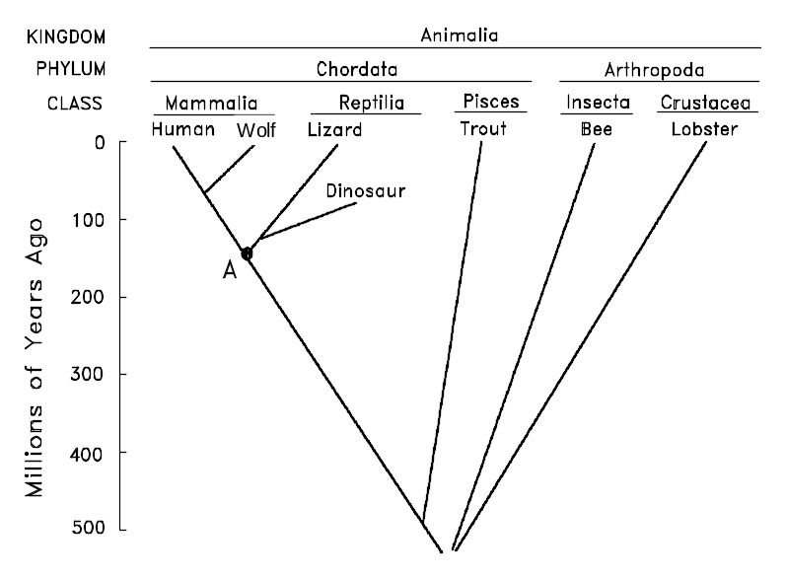
Another way of showing the evolutionary relationship between organisms is in the form of a phylogenetic tree (Gk. phylon, stock, tribe + genus, birth, origin) (Fig. 1). The vertical axis in this figure represents time. The point at which two lines separate indicates when a particular lineage split. For example, we see that mammals diverged from reptiles about 150 million years ago. The point labeled “A” indicates the most recent common ancestor shared by mammals and reptiles. The horizontal axis represents, in a general way, the amount of divergence that has occurred between different groups; the greater the distance, the more different their appearance because of divergent evolution. Note that because they share a fairly recent ancestor, species within the same taxonomic group (e.g., class Mammalia) tend to be closer to each other at the top of the tree than they are to members of other groups.
Figure 1. Phylogenetic tree
Several types of evidence can elucidate the evolutionary relationships among organisms, whether in the form of a taxonomic classification (Table 1) or a phylogenetic tree (Fig. 1). One approach, as already discussed, is to compare living species. The greater the differences between them, the longer ago they presumably diverged. There are, however, pitfalls with this approach. For example, some species resemble each other because they independently evolved similar structures in response to similar environments or ways of life, not because they share a recent common ancestor. This is called convergent evolution because distantly related species seem to converge in appearance (become more similar). Examples of convergent evolution include the wings of bats, birds, and insects, or the streamlined shape of whales and fish. At first glance, it might appear that whales are a type of fish. Upon further examination, it becomes apparent that this resemblance is superficial, resulting from the fact that whales and fish have adapted to the same environment. The presence of hair, the ability to lactate, and homeothermy clearly demonstrate that whales are mammals. Thus, a taxonomist must take into account a whole suite of characteristics, not just one.
The fossil record can also be helpful for constructing phylogenetic trees. For example, bears were once thought to be a distinct group within the order Carnivora. Recently discovered fossils, however, show that they actually diverged from the Canidae (e.g., wolves) recently in evolutionary history. The use of fossils is not without its problems. The most notable of these is that the fossil record is incomplete. This is more of a problem for some organisms than others. For example, organisms with shells or bony skeletons are more likely to be preserved than those without hard body parts.

Materials:

Meter sticks
Scissors
Tape
Paper
Plastic ruler
Transparent tape
pencils
label tape for hanging phylogeny
extra copies of species pages

Procedures:
In this lab, you will develop a taxonomic classification and phylogenetic tree for a group of imaginary organisms called Caminalcules after the taxonomist Joseph Camin who devised them. At the end of this exercise, are pictures of the 14 "living" and 58 "fossil" species that you will use. Take a look at the pictures and note the variety of appendages, shell shapes, color patterns, etc. A number, rather than a name, identifies each species. For fossil Caminalcules, there are also numbers in parentheses indicating the geological age of each specimen in millions of years. Most of the fossil Caminalcules are extinct, but you will notice that a few are still living (e.g., species #24 is found among the living forms but there is also a 2 million year old fossil of #24 in our collection).
The purpose of this lab is to illustrate the principles of classification and some of the processes of evolution (e.g., convergent evolution). We do these exercises with artificial organisms so that you will approach the task with no preconceived notion as to how they should be classified. This means that you will have to deal with problems such as convergent evolution just as a taxonomist would. With real organisms you would probably already have a pretty good idea of how they should be classified and, thus, miss some of the benefit of the exercise.

Exercise 1: The Taxonomic Classification of Living Caminalcules
Carefully examine the fourteen living species and note the many similarities and differences between them. On a sheet of notebook paper, create a hierarchical classification of these species using the format in the table below. Keep in mind that the table is just a hypothetical example and your classification will look quite different from this one.
PHYLUM CAMINALCULA
CLASS 1 |  |  |  |  |  |  | CLASS 2
ORDER 1 |  |  |  |  |  |  | ORDER 2 |  |  | ORDER 3
FAMILY 1 |  |  |  |  | FAMILY 2 |  | FAMILY 3 |  |  | FAMILY 3
GENUS 1 |  | GENUS 2 |  | GENUS 3 | GENUS 4 |  | GENUS 5 |  |  | GENUS 6
1 | 2 | 3 | 4 | 5 | 6 | 7 | 8 | 9 | 10 | 11 | 12

The first step in this exercise is to decide which species belong in the same genus. Species within the same genus share characteristics not found in any other genera (plural of genus). The Caminalcules numbered 19 and 20 are a good example; they are clearly more similar to each other than either is to any of the other living species, so we would put them together in their own genus. Use the same procedure to combine the genera into families. Again, different genera within a family should be more similar to each other than they are to genera in other families. Families can then be combined into orders, orders into classes and so on. Depending on how you organize the species, you may only reach the level of order or class. You do not necessarily have to reach level of Kingdom or Phylum.

Exercise 2. The Comparative Approach to Phylogenetic Analysis
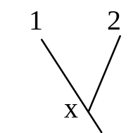
Construct a phylogenetic tree based only on your examination of the 14 living species. This tree should reflect your taxonomic classification. For example, let us say you have put species 1 and 2 into the same genus because you think they evolved from a common ancestor (x). Their part of the tree would look like the diagram on the right.
When there are three or more species in a genus you must decide which two of the species share a common ancestor not shared by the other(s). This diagram indicates that species 3 and 4 are more closely related to each other than either is to 5. We hypothesize that 3 and 4 have a common ancestor (y) that is not shared by 5. Similarly, two genera that more closely resemble each other than they do other genera presumably share a common ancestor. Thus, even in the absence of a fossil record, it is possible to develop a phylogenetic tree. We can even infer what a common ancestor y might have looked like.
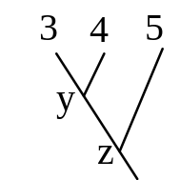

Exercise 3. The Phylogeny of Caminalcules
Using a large sheet of paper, construct a phylogenetic tree for the Caminalcules. Use a meter stick to draw 20 equally spaced horizontal lines on the paper. Each line will be used to indicate an interval of one million years. Label each line so that the one at the bottom of the paper represents an age of 19 million years and the top line represents the present (0 years).

Cut out all the Caminalcules (including the living species). Put them in piles according to their age (the number in parentheses). Beginning with the oldest fossils, arrange the Caminalcules according to their evolutionary relationship. Figure 2 shows how to get started.
73
74
58
?
?
?
19
18
17
Millions of Years Ago

Figure 2

Hints, Suggestions and Warnings
a. Draw lines faintly in pencil to indicate the path of evolution. Wait until your instructor has checked your tree before you glue the figures in place and darken the lines.

b. Branching should involve only two lines at a time:
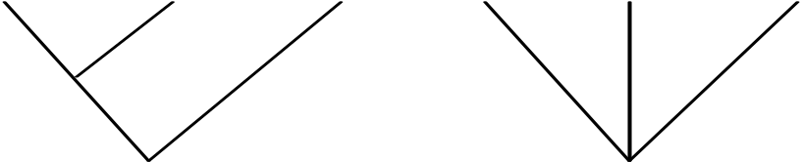
Like this Not this
c. Some living forms are also found in the fossil record.

d. There are gaps in the fossil record for some lineages. Also, some species went extinct without leaving any descendants (remember the dinosaurs, Fig. 1).

e. The Caminalcules were numbered at random; the numbers provide no clues to evolutionary relationships.

f. There is only one correct phylogenetic tree in this exercise. This is because of the way that Joseph Camin derived his imaginary animals. He started with the most primitive form (#73) and gradually modified it using a process that mimics evolution in real organisms. After you complete your phylogeny compare it with Camin's original.

Questions:
  - You will notice that some lineages (e.g., the descendants of species 56) branched many times and are represented by many living species. Discuss the ecological conditions that you think might result in the rapid diversification of some lineages (A real world example would be the diversification of the mammals at the beginning of the Cenozoic, right after the dinosaurs went extinct).

  - Some lineages (e.g., the descendants of species 58) changed very little over time. A good example of this would be “living fossils” like the horseshoe crab or cockroach. Again, discuss the ecological conditions that might result in this sort of long-term evolutionary stasis.

  - Some Caminalcules went extinct without leaving descendents. In the real world, what factors might increase or decrease the probability of a species going extinct?

  - Find two additional examples of convergent evolution among the Caminalcules. This means finding cases where two or more species have a similar characteristic that evolved independently in each lineage. The wing of bats, birds and bees is an example of convergence since the three groups did not inherit the characteristic from their common ancestor. Write your answers in complete sentences (e.g.,“Species x and y both have ____ but their most recent common ancestor, z, did not”). List two additional real-world examples of convergent evolution (ones that we have not already talked about in class) and discuss what might have caused the convergence.

5. a. Describe two examples of vestigial structures that you can find among the Caminalcules. These are structures that have been reduced to the point that they are virtually useless. Ear muscles and the tailbones are examples of vestigial structures in our own species.

b. Explain how vestigial structures provide clues about a species’ evolutionary past. Illustrate your argument with vestigial structures found in humans or other real species.

LIVING CAMINALCULES
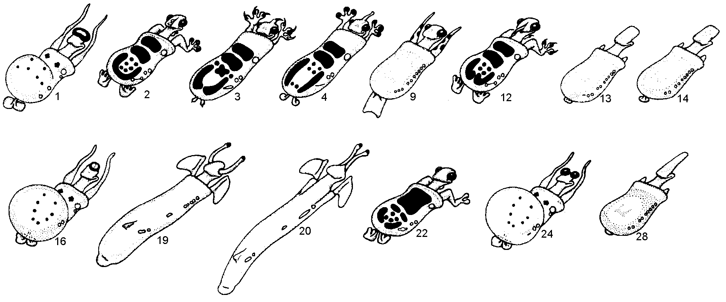
FOSSIL CAMINALCULES
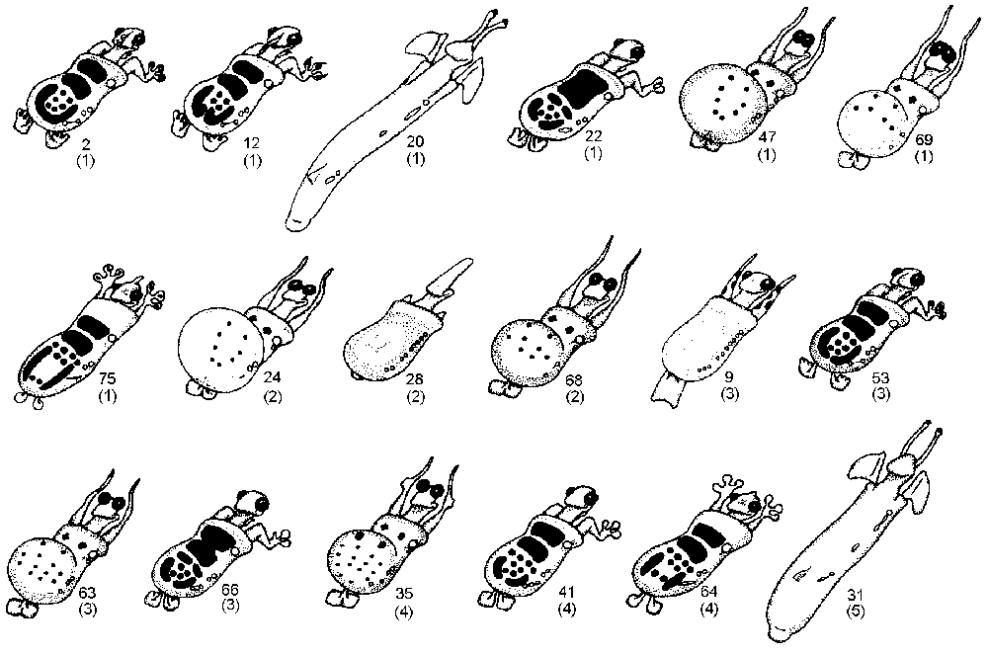(numbers in parentheses indicate age in millions of years)

FOSSILS (continued)
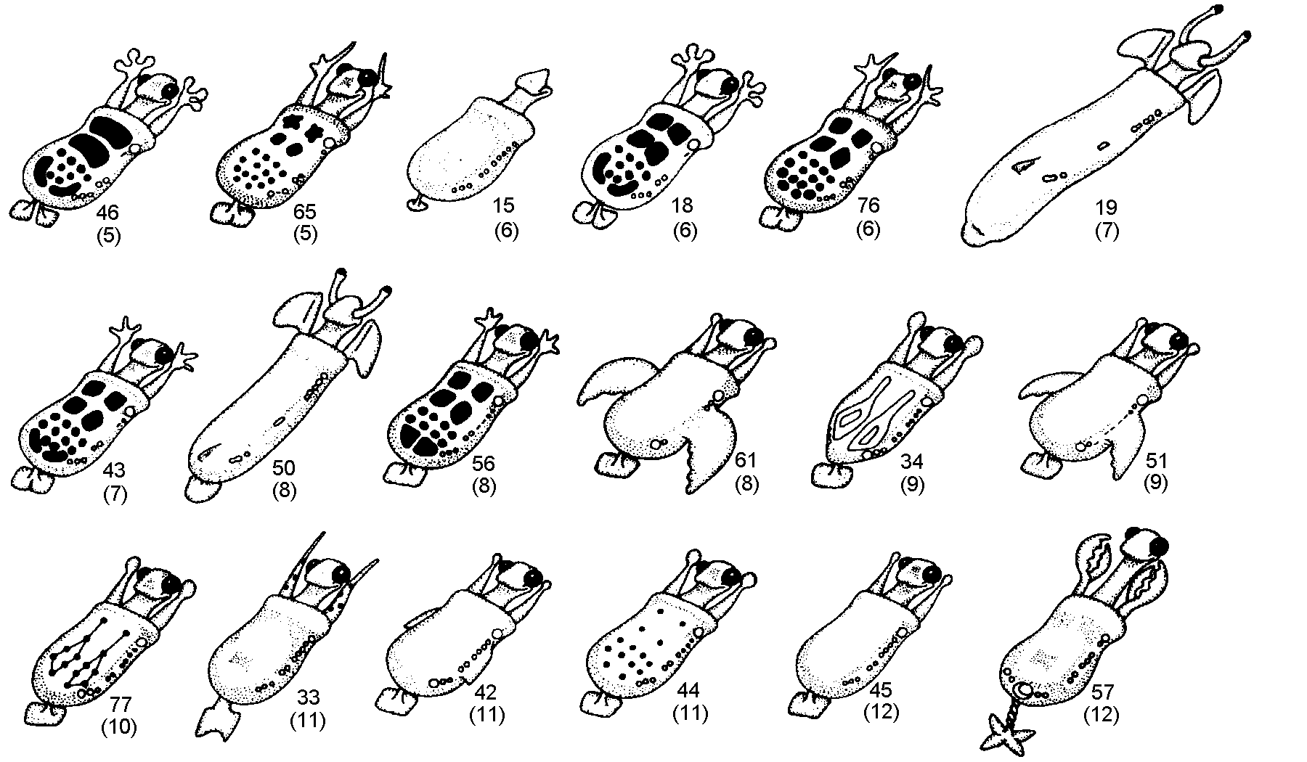

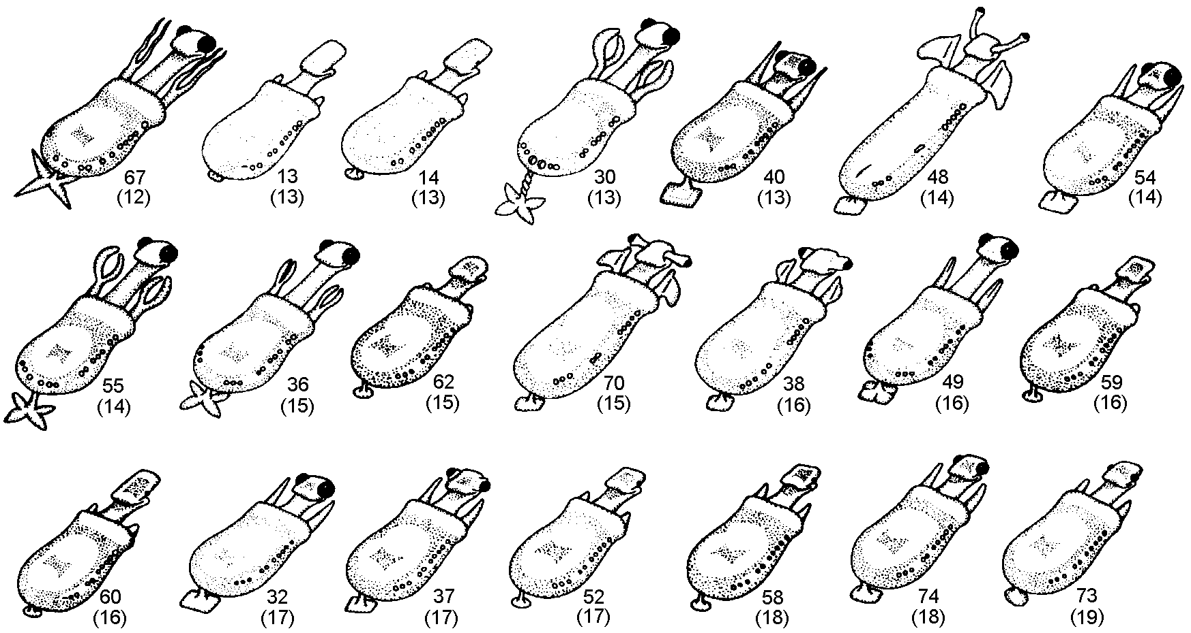
Week 7

BACTERIA AROUND US

Preparation: Bring your dissection kit to class.

Objectives:
- Culture bacteria from various locations
- Describe bacteria colony morphology
- Become familiar with gram staining technique
- Observe phenotypic differences
- Observe antibiotic sensitivity

Introduction:
Bacteria are a diverse group of organisms found in every environment. These single-celled creatures are prokaryotic unlike the eukaryotic cells of fungi, protists, plants, and animals. Many species have adapted to a particular niche, allowing the species to exploit the resources necessary for survival. Human pathogens would not fare well in an environment where lithotrophic bacteria thrive, just as Salmonella spp. would not survive in solutions of dissolved minerals.
Bacteria growing on agar plates will eventually give rise to a colony composed of millions of cells. The resulting morphology is due to the species of the bacteria and environmental factors. Escherichia coli, for instance, generally appear as grey, smooth colonies, while certain species of Bacillus, appear as translucent filaments when viewed under low magnification. Thus the shape and textural qualities of bacterial colonies can aid identification. The color of a colony can also be helpful to differentiate bacteria of closely related species. For example, Staphylococcus epidermidis is white but the closely related Staphylococcus aureus is gold.
Historically, staining bacteria has been used as an initial step in identification. There are many types of staining procedures that exploit attributes of bacteria, some of which are simple and allow visualization while others are differential stains that aid in classification. The most common is the Gram Stain where bacteria in question are stained successively with Gram’s crystal violet and Gram’s safaranin. This relatively simple assay is useful to classify bacteria as gram-negative or gram-positive. The assay yields direct data on the composition of the organism’s cell wall. When treated with iodine, gram-positive bacteria retain the crystal violet in their thick layer of peptidoglycan. The iodine increases the affinity of the crystal violet for the cell wall and is trapped during the decolorization step. Gram-negative bacteria also have peptidoglycan in their cell walls, but since the layer is relatively thin, the crystal violet-iodine complex is washed out during decolorization and retains only the safaranin.
Bacteria are also metabolically diverse. Even among closely related species, nutritional needs may be significantly different. These differences can be exploited and used to putatively identify unknown organisms or select for bacteria that exhibit a particular phenotype. One technique is to grow bacteria on selective media that encourages or inhibits growth depending upon the phenotype of the organism. Similarly, differential media are used to distinguish two closely related bacteria that have small phenotypic differences.

Materials:

Wash bottles of distilled water
Iodine solution
Crystal violet solution
Safarnin stain solution
95% ethyl alcohol
Bibulous Paper
Water-resistant markers
Inoculating Loops
Forceps
Sterile Swabs
Antibiotic discs
Tongue depressors
Bunsen burners
Matches
Ruler
Disinfectant
Test tubes with Sterile Water
Transfer Pipets
Blood Agar plates
Mannitol Salt Agar plates
Nutrient Agar plates
Mueller-Hinton Agar plates
Eosin/Methylene Blue Levine Agar plates
Bacteria Cultures
Stereomicroscopes
Compound Microscopes
Microscope slides
Cover slips
Prepared Commercial slides
Methylene blue stain

Procedures:

I. Growing bacteria from various sources

WEEK 7
- Groups should obtain one nutrient agar plate and label it with the source of bacteria and the initials for each group member. Possible places to sample are the air, soil, dust and restroom surfaces as well as other students.
- Use sterile swabs to collect samples from solid surfaces or humans. Sample the air by exposing the agar surface to the air, preferably in a drafty area for 10 minutes.
- Invert the plates and incubate them at room temperature for one week.

WEEK 8
- Record the results in your lab notebook, e.g., number of morphotypes, size, shape and color of colony morphology, etc.
- Wipe the bench with disinfectant and allow drying.
- Set up the stereomicroscope.
- Create a table in your notebook to describe the colony morphologies.
- With the lid on, place the plate on the stereomicroscope stand and observe the colony morphology for each species. Use the terms in Figure 1 to describe the appearance of colony morphology. Record this data in your table.
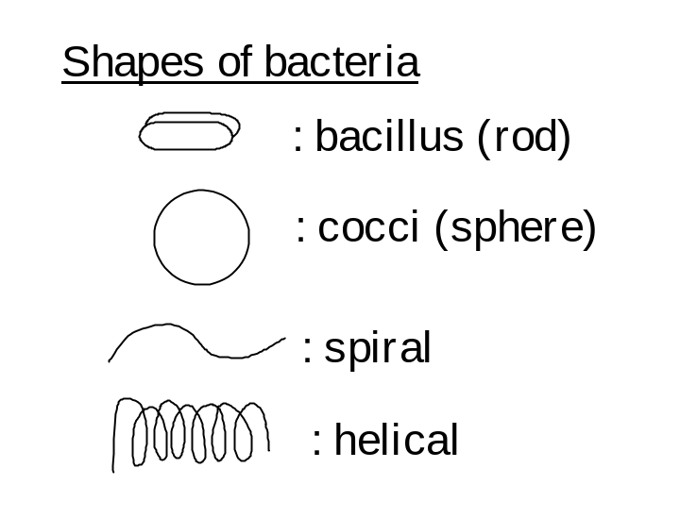
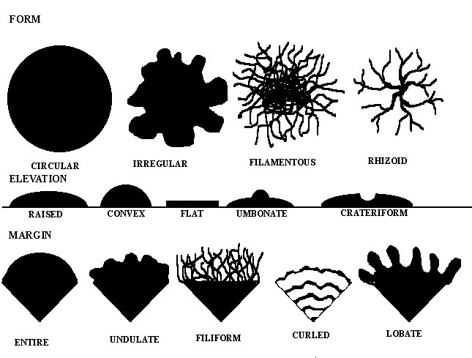
Fig. 1. Colony Morphology Descriptions

II. Gram Stain

- Label a slide with the name of the bacterial species and light the Bunsen burner.
- Obtain bacteria for staining. Each group member must stain a different isolate.
- Using a water-resistant marker, draw a square (approximately 1cm²) on the bottom surface of the microscope slide where you will place your specimen.
- Place a drop of distilled water in the middle of the marked area on the microscope slide.
- Using a sterilized inoculating loop, delicately touch a colony (If you have too many bacteria, the slide will look like a blob!) and then resuspend the bacteria in the drop of water on the slide. Smear the suspension over the slide so that it covers approximately 1cm². Allow the water to evaporate.
- Hold one end of the slide with the forceps and place the slide over the flame for 5-6 seconds, slowly moving back and forth over the flame. The slide should be warm but not hot. DO NOT place the slide in the flame or the glass will break.
- Hold the slide by the edges over the sink and cover the smear with crystal violet. Let stand for 1 minute.
- Tilt the slide and rinse the smear with distilled water. Allow the water to run over the smear.
- Cover the smear with iodine. Let stand for 1 minute.
- Rinse the excess iodine off with distilled water.
- Decolorize the smear by rinsing with 95% ethanol until the run-off is colorless, i.e., 10-15 drops. Do not exceed 30 seconds of destaining. Briefly rinse the slide with distilled water to remove excess ethanol.
- Cover the smear with safaranin, let stand for 1 minute, then rinse with distilled water.
- Dry the slide by blotting with bibulous paper, add a coverslip, and examine under the compound microscope. Examine your partner’s slide also. You will have to use the 100X oil immersion objective.
- Record the results with a drawing of the gram morphology (gram stain and cell shape) in your lab notebook. Shapes include rod, cocci (round), and spiral.

III. Differential Tests

Blood Agar
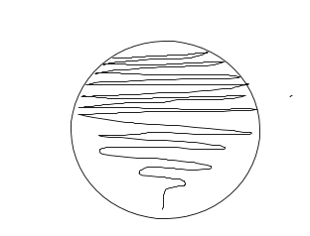
Blood agar is used diagnostically to detect the presence of organisms producing hemolysins, known to destroy red blood cells. There are two types of hemolysis: alpha-hemolysis in which colonies appear greenish when grown on blood agar due to incomplete destruction of hemoglobin, and beta-hemolysis in which the colonies clear an area on the agar due to complete destruction of hemoglobin.
Fig. 2

- Label the bottom of two blood agar plates with your name, date and area sampled.
- Moisten a sterile swab with sterile water and swab a superficial area of the skin.
- Inoculate a plate of blood agar by rubbing the swab over and area of the plate and streaking the specimen over the rest of the plate as shown by your instructor (Fig. 2).
- Obtain a specimen from the throat. Use a tongue depressor to swab the back of the throat avoiding the roof of the mouth and the anterior part of the throat. Swab quickly to avoid gagging.
- Inoculate a blood agar plate.
- Stack your plates in the designated area so your instructor can incubate the inverted plates at 37 C for 24 hours and then place them in a cold room for later observation.
- Make observations of the plates next week. What types of hemolysis were observed on each plate?

Eosin/Methylene Blue Levine (EMBL) Agar
EMBL agar is a medium that is both selective and differential and is used specifically to detect gram-negative intestinal pathogenic bacteria. Methylene blue in the agar inhibits the growth of gram-positive organisms and, with eosin, changes colors in the presence of acids. The medium also contains lactose, and organisms that can metabolize lactose produce acids that cause a color change. The change in color can be from a dark green to a light pink; the difference in color is due to the degree of acid production. Organisms that cannot ferment lactose develop colonies that are non-colored.

- Label the bottom of the plate with your name and date.
- Divide the plate into three sections by writing on the bottom of the plate as demonstrated by your Instructor. Label each section with one of the following species: Staphylococcus aureus, Eschericia coli, and Enterobacter aerogenes.
- Flame-sterilize your inoculating loop.
- Dip it into the culture with the appropriate bacteria and withdraw it. Tap the handle of the loop to remove excess bacteria.
- Streak the bacteria over the appropriate area of the plate in a zig-zag fashion, be careful not to gouge the agar.
- Repeat the above procedure until the all three species have been inoculated to the plate.
- Place the plates in the designated area so the Instructor can incubate the inverted plates at 37 C for 18 to 24 hours, then store them in a cold room until observation next week.

Mannitol Salt Agar (MSA)
Mannitol salt agar is a differential selective media for the isolation of Staphylococcus. 7.5% sodium chloride is present in the agar, which inhibits the growth of gram-negative bacteria. MSA also contains sugar mannitol, which many organisms cannot ferment, and the dye phenol red. Phenol red dye is red at an alkaline pH and turns yellow at a pH less than 6.8. Organisms that are able to ferment mannitol produce organic acids, which lower the pH and cause the agar to turn yellow. Few organisms are able to ferment mannitol and these organisms will not cause a color change.

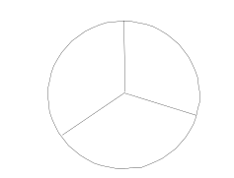
- Label the bottom of the plate with your name and date.
Fig. 3
- Divide the plate into three sections by writing on the bottom of the plate (Fig. 3). Label each section with one of the following species: Staphylococcus aureus, Eschericia coli, and Staphylococcus epidermis.
- Flame-sterilize your inoculating loop.
- Dip it into the culture with the appropriate bacteria and withdraw it. Tap the handle of the loop to remove excess bacteria.
- Streak the bacteria over the appropriate area of the plate in a zig-zag fashion; be careful not to gouge the agar.
- Repeat the above procedure until the all three species have been inoculated to the plate.
- Place the plates in the designated area so the Instructor can incubate the inverted plates at 37 C for 18 to 24 hours, then store them in a cold room until observation next week.

IV. Antibiotic Sensitivity

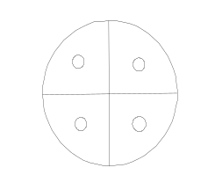
The excessive and unwarranted use of antibiotics in the medical field and their presence in commercial products has lead to the undesired effect of selection for antibiotic-resistant strains of pathogenic bacteria. Antibiotic resistance was first recognized as a problem for medical practices in the 1980s with the emergence of multiple resistant strains of Streptococcus pneumoniae, Staphylococcus aureus, Mycobacterium tuberulosis, and Enterococcus faecalis. Resistant strains of bacteria are more difficult to eliminate during the course of an infection and some of these strains can be lethal. You are going to test the sensitivity of two bacterial species to four different antibiotics (kanamycin, penicillin, tetracycline, and chloramphenicol).
Fig. 4
- Obtain two Mueller-Hinton agar plates and label the bottom of each plate with your names and the bacterial species. One plate will be E. coli and the other will be S. aureus.
- Using a sterile swab inoculate the entire surface of a plate with the appropriate organism.
- Visually divide the plate into four sections and using forceps place a different antibiotic disk into each section. (Fig. 4). Gently tap the disks down into the agar using sterile forceps. Make sure you sterilize forceps between placements of each disk.
- Place the plates in the incubator at 37 C for 18 to 24 hours by your Instructor.
- Next week, measure the zones of inhibition around each disk (in millimeters) with your ruler. Record the data in your lab notebook. Also, note if any colonies are growing within the cleared areas. Compare the results of the disks on each bacterial species.

Questions:
- Are all of the colonies on your plates the result of bacterial growth? If not, explain what else may be growing on the agar.

- Explain why there are different kinds of bacteria from the different sample locations.

- E. coli is able to grow on EMBL but S. epidermidis grows poorly or not at all. Explain this difference.

- Why is the agar surrounding the S. aureus colony yellow on the MSA plate?

- Compare the EMBL and MSA plates. Which species grows better on each plate? What does this tell you about the bacteria?

- Compare the effectiveness of each antibiotic disk on the two species. Were the zones of inhibition the same on both plates for each disk? Were any colonies growing in the cleared areas?

NOTE: Your laboratory report should address Differential Tests and Antibiotic Sensitivity only, not Growth of bacteria from various sources or Gram Stain. However, you are responsible for information about all tests in your lab notebook.

Week 8

PROTISTA

Preparation: Bring your dissection kit to class.

Objectives:
- Become familiar with basic characteristics of Paramecium, Amoeba, and Euglena.
- Identify Protists from local pond or stream water.
- Gain familiarity with binary fission and conjugation reproduction of Paramecium.
- Understand osmosis and hypo/hyper-tonic solutions.

Introduction:
The Kingdom Protista has long been a taxonomic ‘dumping ground’ for organisms that do not truly fit into the other kingdoms. The majority of Protists are single-celled organisms. These organisms range from ciliates, flagellates, algae, seaweed, and water molds. Today, we are going to look at a variety of these organisms.

Materials:
Sporulating Phytophthora parasitica culture
Forceps
Water sample from Lake Erie Center Pond
Mixed protist culture
Commercial slides of Euglena, Amoeba proteus, Saprolegnia, Paramecium cadatum, and Paramecium reproduction
Microscope slides and cover slips
Compound microscope
Stereomicroscope
Beaker of salt water

Procedures:

- Record results from Week 7 laboratory.
- Review how to write a formal lab report. A 20-point lab report will be due next week. Your laboratory report should address Differential Tests and Antibiotic Sensitivity only, not Growth of bacteria from various sources or Gram Stain. The format is outlined in your syllabus.

- Observe commercial slides for the organisms described below and sketch a representative in your lab notebook.

Paramecium:
Parameciums are single celled organisms with cilia covering their entire surface (see commercial slide Paramecium cadatum under compound microscope 40X). The cilia aid in movement and food capture. The oral grove acts as a ‘mouth’; the vacuoles contain water and help keep osmotic balance within the cytoplasm. The nucleoli and the nucleus contain the genetic material for the organism, and the lysosomes break down ingested food.

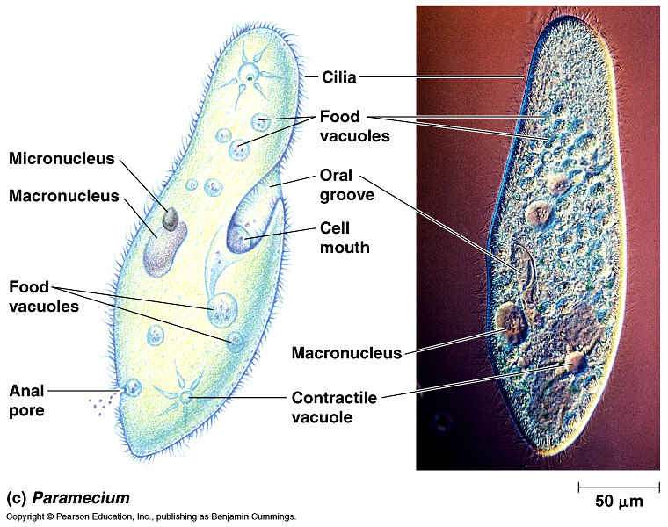

Euglena:
Euglena is unusual because it has chloroplasts. These are the green colored structures. Chloroplasts capture energy from the sun and create food for the Euglena. This makes this organism autotrophic (makes its own food). Organisms that ingest food are known as heterotrophic. Euglena is a flagellate; it possesses a single flagellum by which it propels itself through water. In this lab, you will become familiar with Euglena by observing commercial slides using a compound microscope at 400X magnification.

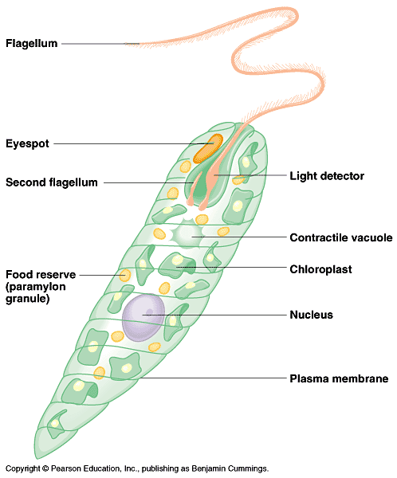
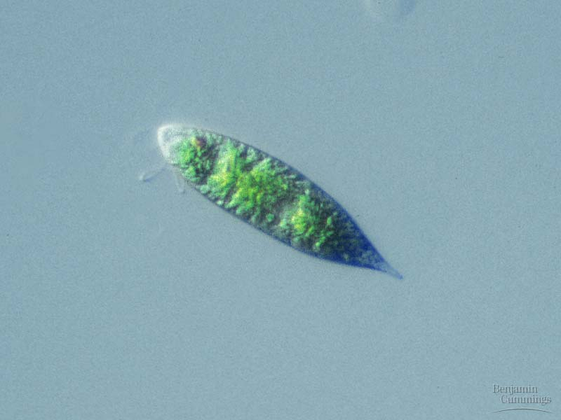

It is believed that the chloroplasts themselves were once free-living organisms. Through evolutionary time, chloroplasts were engulfed by Euglena and began a symbiotic relationship. This theory is known as Endosymbiosis.
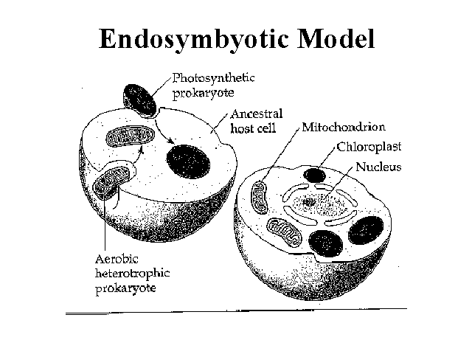
Amoeba:
Amoeba are ubiquitous in freshwater. They move slowly with pseudopodia (false feet) by streaming of cytoplasm to bulges that form under the plasma membrane. Pseudopodia also aid in the capture of food.

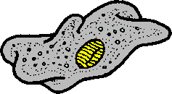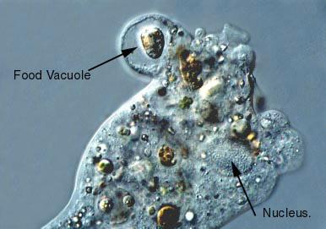

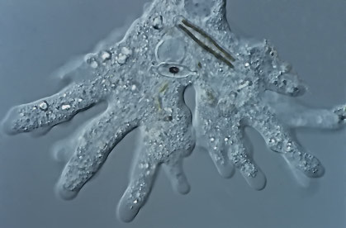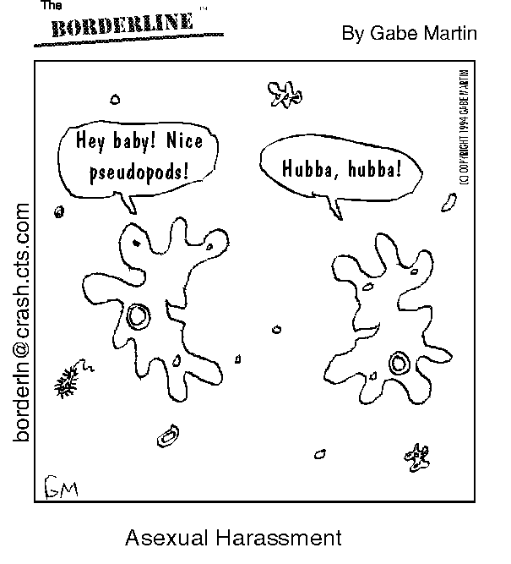

Protist Reproduction:
The majority of protists reproduce asexually via binary fission. Binary fission occurs when an organism duplicates its own DNA and organelles and then splits into two equal living organisms. An exception to this rule is a process known as conjugation by Paramecium. During conjugation, two Paramecium separate sister chromatids, connect to each other at the oral grove, and then chromatids are exchanged. No new organism is created, but the two are changed via the exchange of the genetic material. The Instructor will provide you with slides prepared in advance of class so that you can observe Paramecium in various stages of binary fission and conjugation.

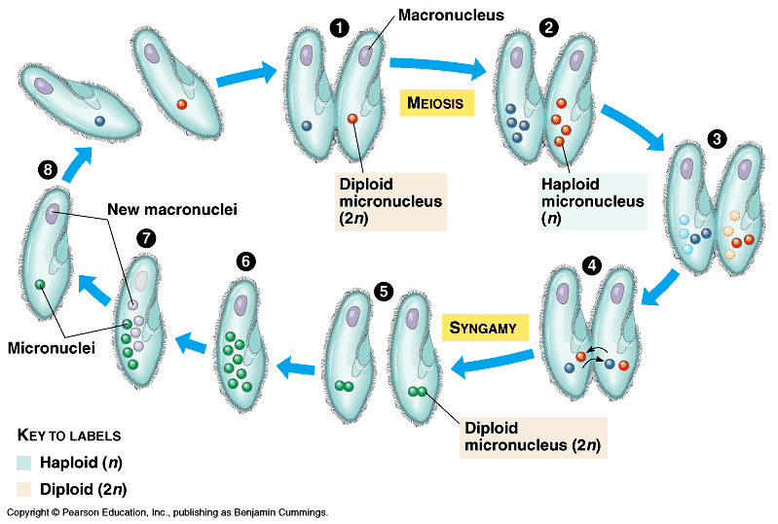

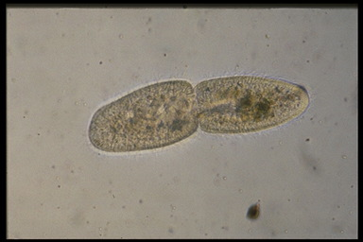
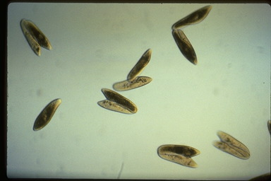
Binary Fission of Paramecium caudatum Conjugation of Paramecium caudatum

Water molds:
Examine the morphology of a fungus-like protist, Phytophthora parasitica. This organism is a water mold that was isolated from tomato farm soil in the Central Valley of California. Water molds (and many algae) produce and release motile zoospores from structures called sporangia. This is asexual reproduction. The water mold will be grown and prepared by the lab Instructor. Change in temperature (refrigerator to lab room temperature) will trigger a release of the zoospores to be observed using a stereomicroscope (highest magnification). Your Instructor will provide you with prepared specimens of another water mold, Saprolegnia, to observe under the compound microscope.
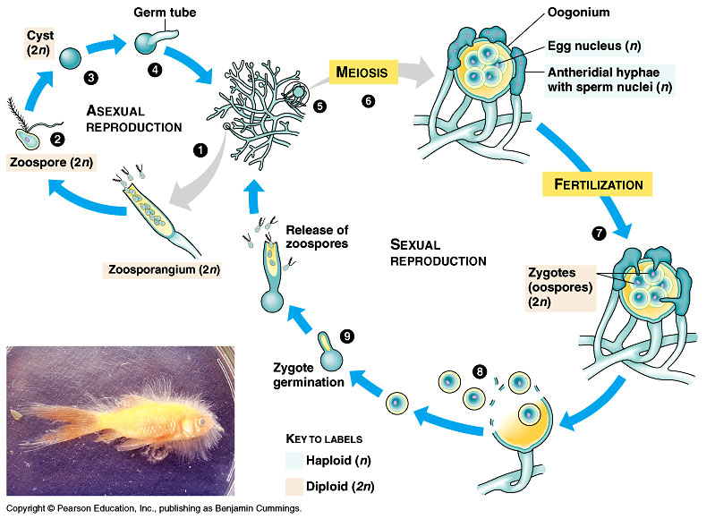

- Prepare microscope slides for living specimens provided to examine under the compound microscope using 400X magnification.

  - Lake Erie Center pond water
  - Mixed protist culture

5. Obtain a paramecium from your instructor. Place it onto prepared microscope slide (using distilled water and place cover slip. Add small drop of salt water next to one corner of cover slip and to help draw the distilled water from under the cover slip place a paper towel at opposite side of cover slip. Observe response of paramecium to conditions. Note whether the vacuole is filling or contracting.

Activity and Questions:

- Draw and label three organisms from the pond water culture from the Lake Erie Center.

- Describe the differences between movement with cilia, flagella, and pseudopodia.

- Mitochondria are suspected to be endosymbiotic in origin, why would this be important?

- What are the main differences between binary fission and conjugation in Paramecium?

- Describe what you observed under the stereomicroscope in the water mold experiment.

Week 9

PLANT EVOLUTION

Preparation: Bring your textbook and dissecting kit to lab.

Objectives:
- Know why bryophytes live only in environments where free water is often available.
- Become familiar with the basic structures of moss.
- Recognize the vascular tissue of gymnosperms, and angiosperms.
- Learn the differences among moss, gymnosperms, and angiosperms.

Introduction
In the history of life on Earth, one of the most revolutionary events was the colonization of land, first by plants, and then by animals. Evidence from comparisons of extant land plants and divisions of algae suggests that the first land plants were related to green algae (Charophycea). Bryophytes and vascular plants evolved from green algae over 460 million years ago.
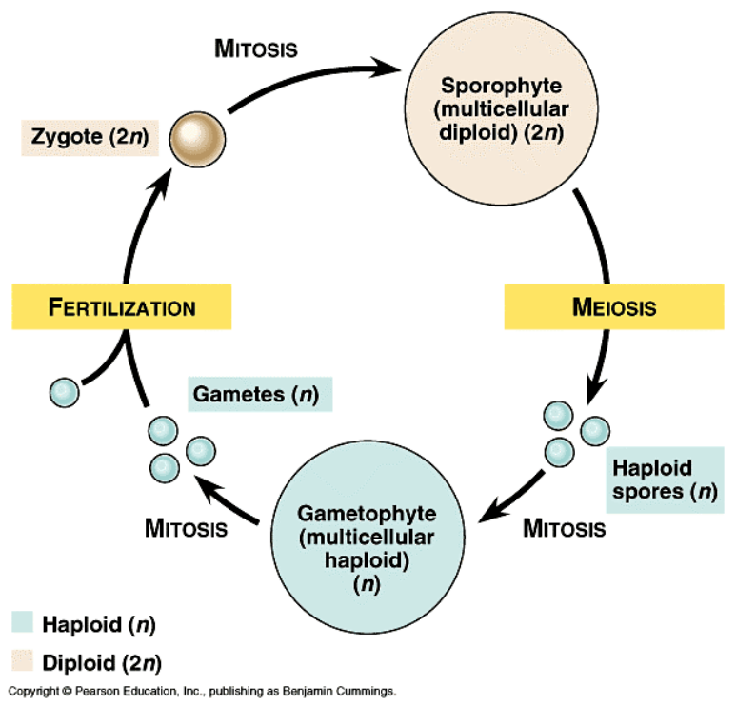Today, flowering plants (Angiosperms) are more numerous and widespread than fruitless plants (Gymnosperms). The Gymnosperms produce seeds and consist of four plant Divisions. Their seeds lack the external layer (fruity part) that surrounds the seeds of flowering plants. Gymnosperms have advanced vascular tissues: xylem for transporting water and nutrients and phloem for transporting photosynthetic products. The cones are reproductive structures. In most gymnosperms, male cones produce microspores that later develop into pollen grains. The pollen grain is transported to a female cone where fertilization occurs; female cones produce megaspores (female gamete). As in gymnosperms, the xylem tissue of angiosperms is composed of tracheids, but also contains large- diameter, open-ended vessels. Angiosperm vascular tissues provide more efficient transport than that of in Gymnosperms.
Fig. 1. Generalized life cycle of plants (Alternation of Generations)
Bryophytes are an ancient group of plants that appear to have evolved into several different groups independently and did not give rise to any other living groups of plants. They are small plants that generally lack true vascular tissue, although water-conducting tubes appear to be present in some mosses. However, these tubes may be unrelated to the vascular tissue in vascular plants. Because bryophytes are nonvascular and have free swimming sperm, they are restricted to moist habitats and have never attained the size and prominence of other groups of plants.

Materials:

moss (Bryophyte)
pine cones (Gymnosperm)
lily (Angiosperm)
Wash bottle
Stereomicroscope
Dissecting needle
Transparent tape
Potted plant with broad, non-variegated leaves
Timer for photoperiods
Light Stand
Scissors
Aluminum foil
Marker pens
posters
Dissection pan
Scalpel
eyedropper
Petri dish to hold moss
beaker
eyedropper

Procedure:
- Obtain a living specimen of a moss.
  - Examine living colonies of mosses on display.
  - Identify the root-like rhizoids at the base of the moss.
  - Wet the moss gametophyte with the wash bottle. Describe the effect and water movement through the moss.
- Examine the pine branch and notice the arrangement of leaves in a bundle. A new twig at the end of the branch is in the process of producing new clusters of leaves.
  - Examine the small cones produced at the end of the pine branch on this specimen.
  - Locate an ovulate cone (female) and a pollen cone (male). Small, elongated male pollen cones are present only in the spring, and produce pollen in overlapping bracts or scales. The larger, more rounded cones on the stem are called ovulate cones. Female cones persist for several years. Observe the overlapping scales, which contain the sporangia, and compare the cones with Fig.2.
- Examine a fresh lily flower.
  - Identify the parts of flowers using Fig. 3. You may be able to determine the floral traits for large, open flowers by simply observing. However, most flowers will require that you remove the floral structures from the outside and work toward the center of the flowers.
  - Dissect the Lily flower as your instructor demonstrated; tape the dissected parts in your notebook, and label them with their respective names.
  - Repeat for a carnation.
- Preparation for Lab 7:
  - Obtain 1 potted plant per pair of students
  - Fully cover one-half of the leaves of the plant with pieces of folded aluminum foil pressed firmly to the leaves to prevent light reaching the leaves; the other half of the leaves should be exposed to light, e.g., if your stem has 10 leaves, cover five and leave five uncovered.
  - Label the plant with your initials and section number. Then, set your experimental unit under the light stand and make notes of the light settings in which your plant is going to be exposed during the following week.
  - List your hypotheses concerning the effect of covering the leaves on the appearance and photosynthetic capacity of the leaves.

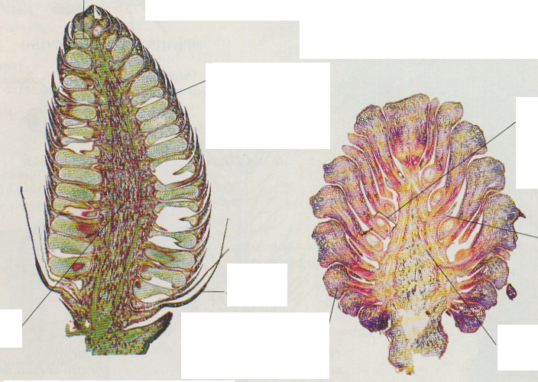
Cone Axis
Longitudinal photomicrograph
cut of an young male cone
Megasporophyll
Scale carrying the ovule
and then the seeds

Microsporophyll
Scale carrying the microsporangium, “pollen grain”

Cone Axis
Foliar Scale
Bract Scale
Megasporangium (Ovule)
Containing female
gametes, “megaspores”
Microsporangium
Structure producing the microspores
Fig. 2 Cone Internal Structure
Longitudinal photomicrograph
cut of a 2nd year female cone

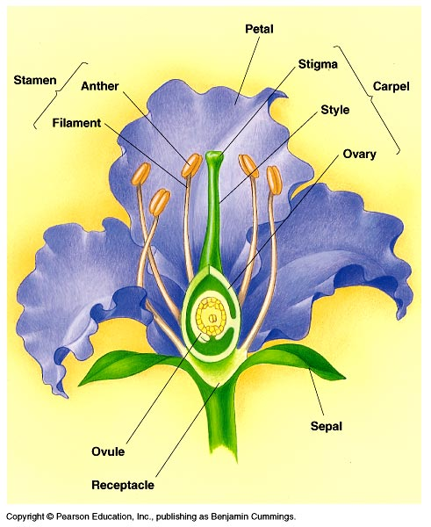

Fig .3. Flower Structure

Questions:

- What are the four Divisions remaining within the Gymnosperms (check in your text book)?

- Why do you think that Angiosperms have succeeded better evolutionarily than Gymnosperms?

- What functions do you think rhizoids perform?

- Based on your observations, what are the differences between true roots and rhizoids?

- What important process occurs in sporangia (e.g., microsporangium and megasporangium)?

- What does alternation of generations mean? Describe it with detail including names of structures, types of cell division, and developmental sequence.

Week 10

PLANT PHYSIOLOGY

Part I: Water transport in a Carnation

Preparation: Bring your dissection kit to lab

Objectives:
- Observe the rates of water transport with the appearance of dye in flower petals.
- Observe the rate of water transport in celery.

Introduction:
Transport in plants occurs on three levels: (1) the uptake and release of water and solutes by individual cells, such as the absorption of water and minerals from the soil by cells of a root; (2) short-distance transport of substances from cell to cell at the level of tissues and organs; (3) long distance transport of sap within xylem and phloem at the level of the whole plant.
When water evaporates out of openings (stomata) on plant leaves, petals or buds, water is pulled up the stem of the plant via transpiration. Transpiration is the process of water transport through roots, vascular tissue, and out stomata. Xylem is the water-conducting tissue that transports both water and dissolved minerals from the tips of roots through the stem to branches, leaves, petals, and buds. In this experiment, you will observe the water transportation rates in a carnation.

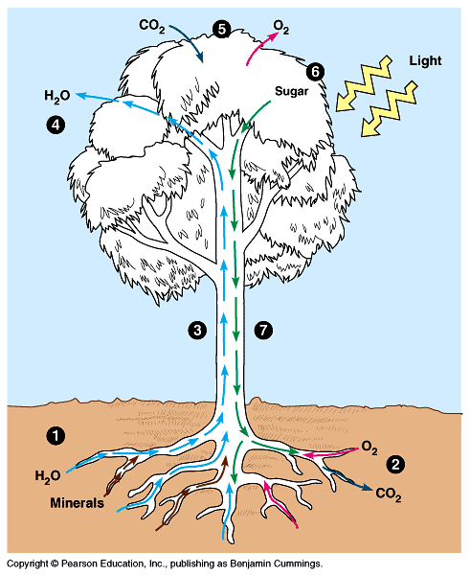
Figure 1. Water and photosynthetic sugars are moved through the xylem and phloem, respectively. A cost associated with photosynthetic CO₂ exchange is water loss through the stomata. The primary process governing water movements is leaf transpiration, which is highly dependant on water potential. Water movement can be easily described by the soil-plant-atmosphere-continuum (SPAC). SPAC illustrates how water moves from negative (soil, -0.3 MPa) to more negative water potentials (plant and atmosphere, -1.0 MPa and –30.1 MPa respectively).

Materials:

Fresh white Carnations
2 buckets with water
Dissecting pan
Two 15-ml test tubes / flower
Test tube rack
Knife
Scissors (in bucket)
Food coloring (red, blue, green)

Celery

Procedures:
- You are going to work in pairs and prepare an experiment to be observed during the next few days.

- Take a white carnation and diagonally cut the bottom of the stem under water, leaving 10-15 cm of stem length. Make the cuts with the carnation submerged in water in a bucket. This reduced stem length allows for reduced dye to travel time.

- Label a test tube and place several drops of dye into it. Add tap water until the tube is nearly full and place the stem into the tube. Place your experimental unit in a test tube on the light stand.

- Repeat procedure (steps 1-3) with celery stalks

- Wait 15-20 minutes and observe the celery and flower’s appearance.

- Wait an additional 60 minutes and observe the flower’s appearance. Note any changes. Leave the plant under the light for a week and re-observe. Then, answer the following questions in your lab notebook

Questions:
- Why is it important for plants to transport water to different parts of the plant?

- Besides water, is there anything else that can be transported via the xylem?

- Describe the experimental result that you have observed and briefly record your interpretation and conclusions.

- Describe the water transport process in plants.

Part II: Light and photosynthesis

Objectives:
- Examine the role of light in plant photosynthesis.
- Evaluate evidence of starch production.

Introduction:
Photosynthesis is the process by which plants, some bacteria, and some protists use the energy from sunlight to produce sugar, which cellular respiration converts into ATP (adenosine triphosphate), the "fuel" used by all living things. The conversion of unusable sunlight energy into usable chemical energy is associated with the actions of the green pigment chlorophyll. Most of the time, the photosynthetic process uses water and releases the oxygen required for respiration of all organisms (Fig. 1).

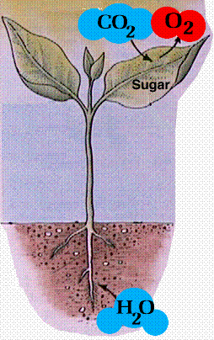

Fig. 1. The process of photosynthesis

The earliest evidence of life on Earth is from 3.5 to 4 billion years ago. The atmosphere was thin: composed of methane, carbon dioxide, and water vapor. Any gaseous oxygen had been used up in the combustion (or oxidation) of materials when the Earth was very hot.
The most widely accepted theory suggests that cooling water collected in pools, assimilating nutrients from rocks. As water evaporated, the nutrients concentrated, forming a rich soup. The first organisms had ample resources in these nutrients, and broke down the complex molecules into water and carbon dioxide through respiration. Eventually, as life evolved, the need arose to re-synthesize complex compounds for both structural components and functions. Some organisms evolved the ability to use the sun's energy to synthesize large molecules from small molecules (autotrophs). Other organisms continued using other sources of reductive power (heterotrophs). Autotrophs are found in both Eubacteria and Plant Kingdoms. Heterotrophs include all other groups of organisms. In this experiment, you will study how light is necessary for photosynthesis.

Materials:

Hot Plates
Mineral Spirits
Test tubes
Beakers
Boiling water
Fume Hood
Iodine solution
Thermal Gloves
Petri dishes
Labeling Tape
Markers
Paper Towel
pipettes

Procedures:
Obtain the plant you have prepared for this experiment last week and follow the steps below:
- Remove the aluminum foil.
- Remove the 2- 4 leaves (depending on leaf size) with foil and 2 - 4 leaves without foil. Keep track of which leaves had foil covering them and which did not.
- Get 2 test tubes: one for the leaves that were covered with the foil and one for the leaves that were exposed to the light. Does the leaf appearance support or refute your hypothesis from last week?
- Depending on relative leaf and tube size, place 3 or 4 leaves into each test tube. Add the mineralized spirits solution until it covers them. The goal is to soften the leaves and remove their chlorophyll and other pigments. Label tubes with wax pencil. Keep leaves weighted down with a washer that fits inside a testtube.
- Add the tubes to a beaker with boiling water until you see discoloration of the leaves (about 15 to 20 minutes). At this point, most chlorophyll will have been removed.
- Decant the mineralized spirits and chlorophyll solution and replace it with hot water.
- After soaking for 5 to 10 minutes in hot water, remove the leaves and spread them on an absorbent paper to stiffen and dry.
- Place the leaves in a Petri dish and cover them with drops of iodine solution (wait 2 minutes).
- Compare treatment 1 and treatment 2 (leaves exposed to light versus leaves shielded from light). Does the presence / absence of starch support or refute your hypotheses about the photosynthetic capacity of the covered leaves?
- Record your experimental results in your laboratory notebook.

Questions:
- What are the functions of mineralized spirits in this experiment?

- What happened after spreading iodine solution on the leaves? Why?

- What conclusion do you make from this experiment?

Week 11

SURVEY OF THE KINGDOM FUNGI

Preparation: Bring your dissection kit and textbook to lab. Become familiar with the reproductive life cycles of the Kingdom Fungi by using the CD-ROM accompanying your text.

Objectives:
- Examine the basic life cycle of bread mold.
- Understand fungal relationships with humans and the environment.
- Identify the different parts of a mushroom.
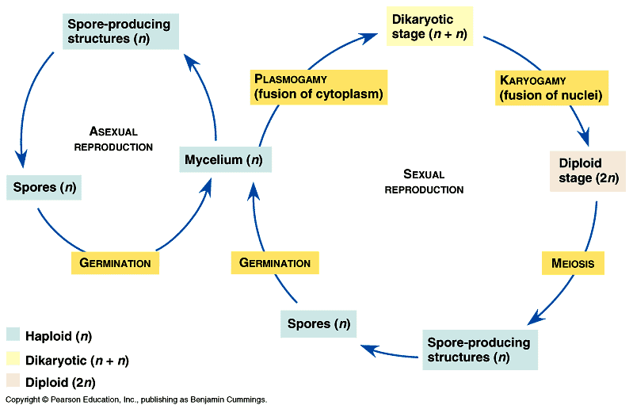

Introduction

The kingdom Fungi includes a diverse group of organisms that play important economic and ecological roles. The three major Divisions of fungi are separated by their reproductive cycles and include the Zygomycota, Ascomycota and Basidiomycota. A fourth group, Fungi Imperfecti, is an artificial rather than phylogenetic classification that includes species with no known sexual, or “perfect” phase.

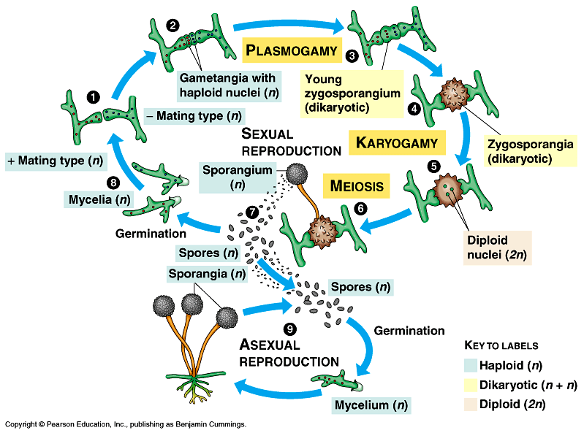
Zygomycota, which include common bread molds, derive their name from resting sexual spores called zygospores. Bread mold (Rhizopus) is a common zygomycete. Its hyphae are modified into rhizoids, stolons, and sporangiophores. Sporangiophores are upright hyphal filaments supporting asexually reproducing sporangia. Within a sporangium, haploid nuclei become spores and are separated by cell walls. These spores are released to the environment when the sporangium matures and ruptures.

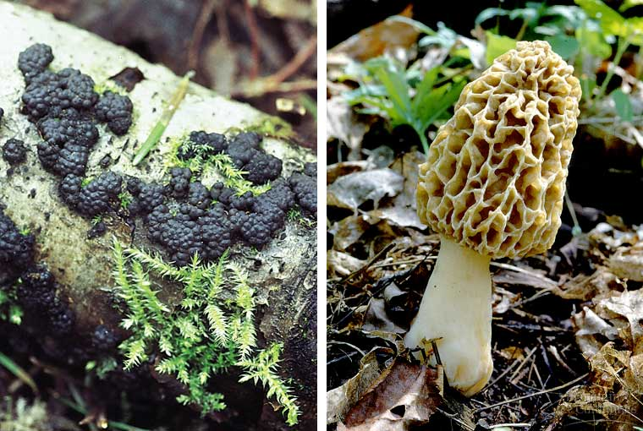
Ascomycota, “sac fungi”, include such organisms as truffles, parasitic powdery mildews, morels, and some yeast. Sexual reproduction in this group results in an ascus that contains spores named ascospores. The asci are enclosed in a fruiting body that forms different shapes such as shallow cups, and globes. This Division not only includes yeast, which is important in brewing and baking, but also Penicillium, from which is derived a common antibiotic.

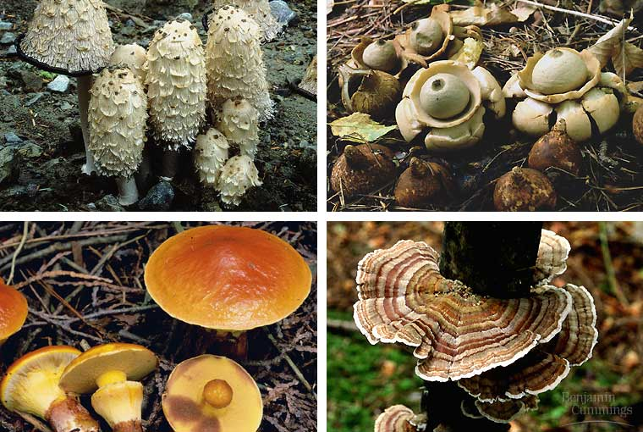
Basidiomycota, the “club fungi”, are probably the most familiar. They include mushrooms, puffballs, shelf fungi and economically important plant pathogens such as rusts and smuts. Mushrooms are familiar examples of the aboveground portions of extensive mycelia that permeate the soil. Examine a mushroom and other representative Basidiomycota on display and note the mushroom’s cap, pileus, and gills on the undersurface of the cap. Gills are lined with microscopic, club-shaped cells called basidia where sexual reproduction occurs.

Materials:

Fresh, ripe mushroom basidiocarps
Prepared slides of Coprinus pileus sections
Prepared Lichen thallus slides
Whole lichens
Moldy bread
Petri dishes
Compound microscope
Stereoscopic microscope
Microscope slides
Scotch tape

Procedures:
1. Observation of bread mold
- Obtain a petri dish from your instructor, which contains a piece of moldy bread that was moistened and exposed to the air for several days.
- Note the velvet texture and various colors of the molds.
- Examine mycelia with a stereomicroscope (10 to 20X magnification);notice that they grow as a tangled mass of hyphae.
- Sketch what you see and identify the mycelia, hyphae and sporangia.
- Take a small piece of scotch tape--avoid contaminating with fingerprints. Lightly touch adhesiveto bread mold and then stick to a microscope slide.
- Examine the hyphae, sporangia, and zygospore (if present) using the compound microscope at 200 and 400X magnification.
- Sketch and identify what you observe.

2. Mushroom dissection
- Obtain a fresh mushroom, a basidiocarp, and identify its parts: stalk (stipe), cap (pileus), and gills. Spores form on the surface of the gills. Slice the cap in half and examine the gills with the stereomicroscope.
- Draw and label the mushroom structures observed.
- Obtain a prepared section of Coprinus pileus to further examine the gills and spores on a compound microscope.
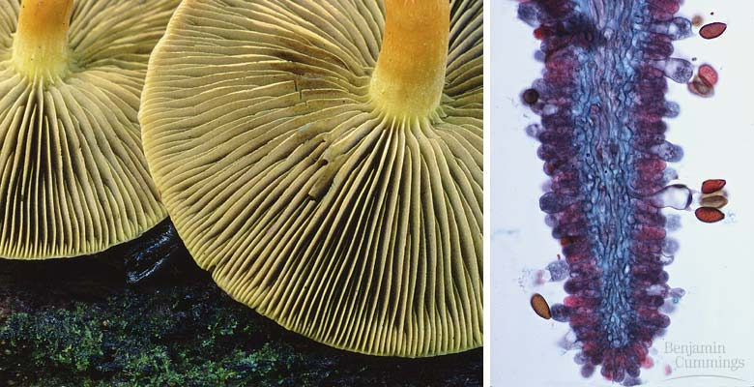
- Using the prepared slide, observe the surface of several gills using 1000X magnification with oil immersion. Spores are produced at the tips of small club-shaped structures called basidia. Locate a basidium and focus carefully on its end. Here you may see four knoblike protuberances.
Left: gills under cap. Right: a single gill lined with basidia (basal structure) and basidiospores (clusters of single-celled spores).
Each protuberance has a haploid nucleus that formed following meiosis, and each becomes a basidiospore. When the spores are mature, they are discharged from the basidium and are dispersed by the wind.
- Draw and label a basidium and basidiospores.

3. Lichens
- Obtain a prepared section of a lichen thallus. Lichens are associations of fungus and one or more photosynthetic organisms (i.e., algae or bacteria).
- Identify the fungal and algal components of the lichen using a compound microscope at 200 and 400X magnification.
- The fungi and algae reproduce independently, but they often form specialized structures called soredia (a form of asexual reproduction). Note if this cluster of hyphae and algae is present on the slide.
- Obtain fresh samples of lichen. Observe their diverse morphologies and identify fungal/algal components.
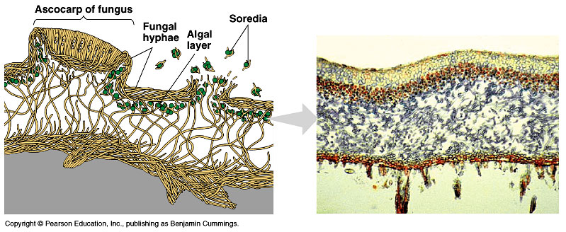
Lichen morphology.

Questions:

- Have any of the hyphae on the bread been modified to produce spores? Are the spores being produced sexually or asexually?

- State the characteristics shared by the Division Basidiomycota.

- Lichens are beneficial associations between algae and fungi. How does each component benefit the other?

4. List several examples of how fungi are economically or ecologically important.

Week 12

INVERTEBRATES

Preparation: Bring your dissection kit to class.

Objectives:
- Determine how pill bugs respond to environmental stimuli.
- Become familiar with the physical characteristics and habitat conditions of pill bugs.

Introduction:
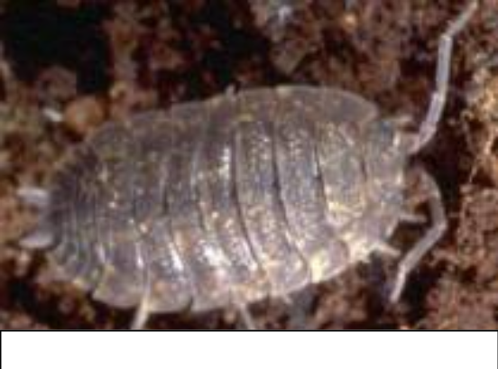 Invertebrates are a group of organisms that lack an internal skeleton. They are usually characterized by insects, but also include sponges, arthropods, echinoderms, and gastropods, among others. Today you will conduct a laboratory experiment on common pill bugs, Armadillidium vulgare (right).
Pill bugs are one of only two crustaceans that have adapted themselves entirely to land. For gas exchange, they have gills instead of trachea, which is the respiratory system of insects. They have oval bodies with seven overlapping plates and seven pairs of legs. The head and abdomen are small compared to the rest of the body; they can reach 2-cm in length. Pill bugs are often called ‘roley poleys’ because they can roll up into a tight ball when disturbed.
Pill bugs are scavengers that feed on decaying organic matter. They require moist locations and are found under objects on the damp ground, as well as under vegetable debris of all types. They may bury themselves several centimeters into the soil and are active mostly at night. The female carries her young in a pale colored vivarium or marsupium on the underside of her body. The young are white in color.

Materials:

Pill bugs
Forceps

Squirt bottle with tap water
Aluminum foil (40 x 40 cm)
Stereomicroscope
Stopwatch
scissors
heating pad
3 9x13 pans
ice
soil
ziploc
thermometer

Procedures
In this experiment, you are going to test if these organisms prefer a) moist or dry habitats and b) dark or light habitats and c) a combination (or double gradient). What do you think will happen? BEFORE you conduct the experiments, write your hypotheses in your laboratory notebook.

1. you will need to be in teams of 3-4. Each team needs 3 9x13 metal containers.
2. Two of the containers will be set up the following way (refer to diagram below):
- take a long sheet of aluminum foil and crimping it (about 1mm high), create 3 shallow areas in pan
- add a thin layer of soil to entire pan (1mm or so)
- make certain foil is arranged so inverts do not go under foil in pan
3. In container 1: in one section make it very wet (soggy), the middle slightly wet and the third
dry
- In container 2: place heating pad under one third of tray and fill Ziploc with ice and place under other end (there should be nothing in middle section)
- Place a thermometer in both the iced and heating pad soils
- Only begin experiment when there is a 10 degree C temperature gradient between the ice and heating pad sections
5. For the container 3:
- Divide in half to create light and dark conditions
- Use foil to block off light (it is up to your group to create the best version of keeping out light)
6. In the final experiment re-use container 1 to further divide it into multiple gradients:
- This is done by covering one side of the container length wise with foil and to create 6 sections/ environments (a double gradient)

Crimped foil
Heat
Medium

Cold
Light
Dark
Wet

Dry

Medium

Container 1
Container 2
Container 3
Wet

Dry

Medium

Double gradient
Using container 1
Foil covered uncovered

7. Add the pre-determined number of pill bugs to the center section of each pan. It is important for all the conditions to be set before beginning to time the bugs. Wait 5 minutes for the pill bugs to adjust to their surroundings. Then, in your laboratory notebook, record how many pill bugs are in each area at 0 (initially), 3, 6, and 9 minutes, organized in the format illustrated below. Repeat this experiment for a total of three times. Compile data among groups to increase numbers of replicates.

Table for container 1
 | Dry | Medium | Wet
0 minutes
3 minutes
6 minutes
9 minutes

Table for container 2
 | Cold | Medium | Heat
0 minutes
3 minutes
6 minutes
9 minutes

Table for container 3
 | Light | Dark
0 minutes
3 minutes
6 minutes
9 minutes

Table for double gradient
 | Dry/Dark | Dry/Light | Med/Dark | Med/Light | Wet/Dark | Wet/Light
0 minutes
3 minutes
6 minutes
9 minutes

Assignment:
Prepare a typed, lab report that is double-spaced. Include your original hypotheses, data you collected, how the data was collected, and if your predictions were supported by the data or not and why.

Week 13

VERTEBRATES: FETAL PIG DISSECTION

Preparation: Bring your textbook to class.

Introduction:
Animalia is the kingdom that we are most familiar with and includes organisms such as humans, dogs, whales, and reptiles. In this exercise, you will study the anatomy of a fetal pig. Pigs are very similar to humans, and much of the experimental cloning of human organs is being conducted on pigs. To allow for easy identification, veins of the pigs have been injected with blue dye and the arteries with red dye. We will be comparing the anatomy of the pig to that of humans as illustrated in your textbook.

Safety:
When conducting dissections, laboratory safety is a must. Because scalpels will be used, please do not wear any type of sandal. This will prevent a cut if any sharp object is dropped. Please use nitrile gloves at all times if you handle the pig. If any cut or injury occurs, please let your lab Instructor know immediately.

Materials

Double-injected fetal pigs
Dissecting pans
Dissection kits
Dissecting pins
Twine
Nitrile gloves
Water-resistant markers

- Your Instructor will direct you to the EEES computer cluster where you will do a virtual pig dissection;

- Go to the web site: http://www.whitman.edu/offices_departments/biology/vpd/main.html

This site has the planes of the body. It is a slide show that shows the planes and then it has the anatomical terms and definitions associated with planes on the last slide.
http://student.brighton.acuk/anatomy/body_planes.htm

This website should be used to observe how the incisions are made.
http://www.esu7.org/~lweb/Lakeview/science/fetal.html

Here is an excellent site that compares the external anatomy of the male and female.
http://www.hillstrath.on.ca/moffatt/bio3a/fetalpig/fpugf01.htm

These sites are links to the digestive, respiratory and circulatory systems. They are real pictures with accompanying text and additional links to observe specific parts of each system.
http://www.hillstrath.on.ca/moffatt/bio3a/fetalpig/fpdsf01.html
http://www.hillstrath.on.ca/moffatt/bio3a/fetalpig/fprsf01.html
http://www.hillstrath.on.ca/moffatt/bio3a/fetalpig/frame01.htm

- Back in the laboratory, you will observe the instructor performing a dissection of a fetal pig. You are expected to follow along in your lab manual as the instructor demonstrates various organ systems. Underline all the structures that you were able to locate.

- Near the end of the laboratory period, obtain a quiz from the instructor. You have 15 minutes to answer the questions.

EXTERNAL ANATOMY

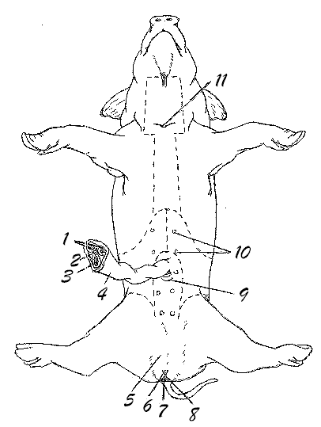
You can locate these parts by matching the numbers on the pig with the corresponding titles.

- umbilical arteries
- allantoic duct
- umbilical vein
- umbilical cord
- scrotum
- genital papilla (female)
- anus
- urogenital opening (female)
- urogenital opening (male)
- mammary papillae

- umbilical arteries: carries oxygen-rich blood to the fetus from the placenta
- umbilical veins: carries deoxygenated blood from the fetus to the placenta
- umbilical cord: connects the fetus to the mother at the placenta
- scrotum: contains the testes
- genital papilla: a projection of tissue dorsal to the urogenital opening
- anus: an opening located ventral to the tail where feces is excreted
- urogenital opening (female): opening to the urogenital sinus
- urogenital opening (male): opening to the urogenital sinus
- mammary papillae: nipples; indicate how many mammary glands there are

NECK AND THORACIC CAVITY (RESPIRATORY SYSTEM)
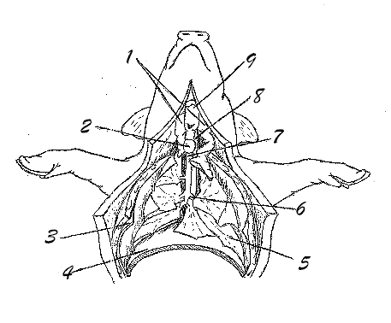
- thymus
- thyroid
- pleural membrane
- diaphragm
- lungs
- bronchi
- trachea
- esophagus
- larynx

- thymus: aids in the development of white blood cells
- thyroid: creates hormones to control cell metabolism
- diaphragm: dome-shaped muscle that contracts to draw air into the lungs; most important organ in respiration
- lungs: respiratory organs that draw in air to be "processed"
- larynx: the voice box; produces sound as air is forced through it

CIRCULATORY SYSTEM
Now it's time to explore and discover one of the most vital systems in the body, the circulatory system. Here, you will discover the major arteries in the pig's body. You will also discover the various and most important parts of the heart.

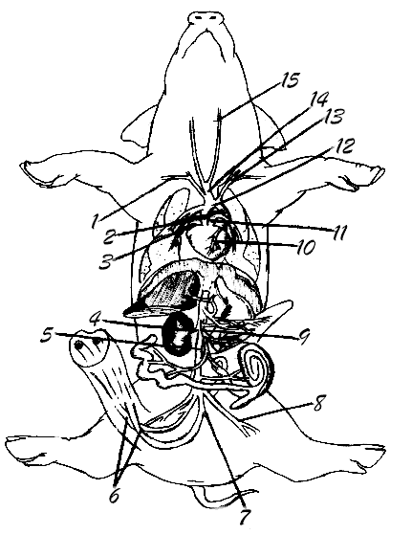
MAJOR ARTERIES

- right subclavian
- ductus arteriosus
- right auricle
- renal
- dorsal aorta
- umbilical
- internal iliac
- external iliac
- anterior mesenteric
- coronary
- pulmonary
- aortic arch
- left subclavian
- brachiocephalic

- common carotid

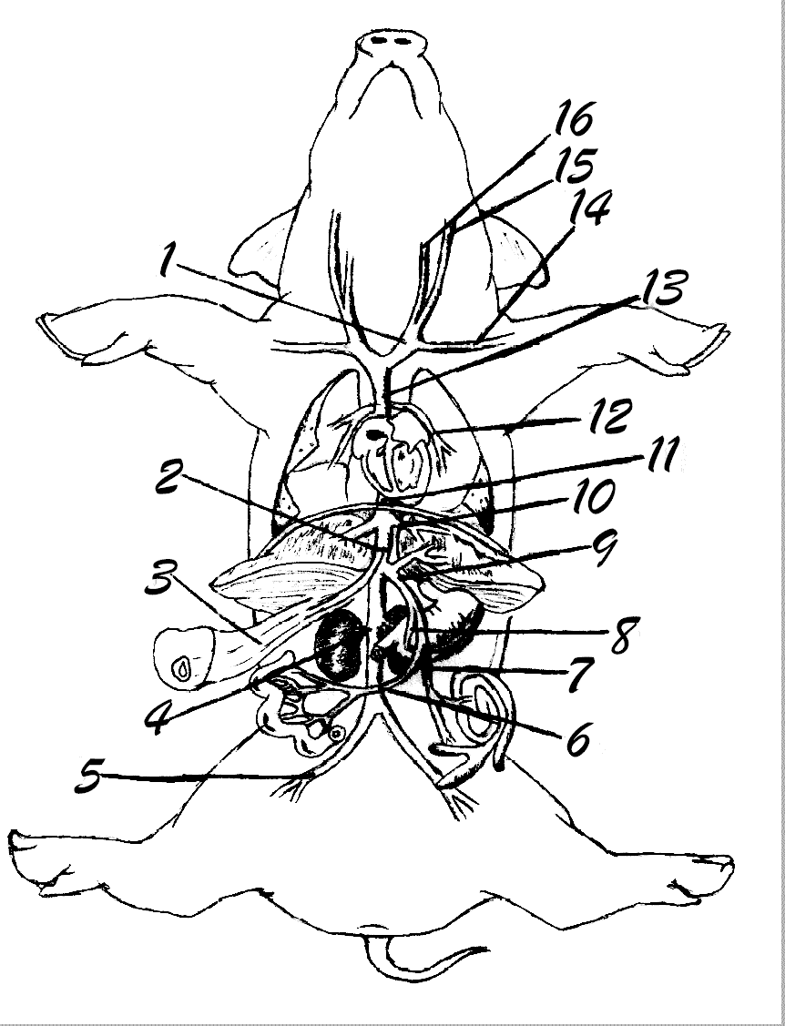
MAJOR VEINS

- brachiocephalic
- ductus venosis
- umbilical
- renal
- common iliac
- superior (anterior) mesenteric
- inferior mesenteric
- gastric
- hepatic portal
- hepatic
- posterior vena cava
- pulmonary
- anterior vena cava
- left subclavian
- external jugular
- internal jugular

- umbilical veins: carries deoxygenated blood from the fetus to the placenta
- renal vein: carries purified blood away from the kidneys

- hepatic portal vein: carries blood from the digestive organs and spleen to the liver where nutrients are altered by hepatocytes before entering circulation
- hepatic vein: carries blood away from the liver
- posterior vena cava: returns blood to the right atrium of the heart
- pulmonary vein: carries oxygenated blood away from the lungs
- anterior vena cava: returns blood to the right atrium of the heart

HEART (DORSAL VIEW) – Remove the heart for better view
(Please note that some of the structures are internal and are not currently viewable, but the arrows indicate their approximate location.)

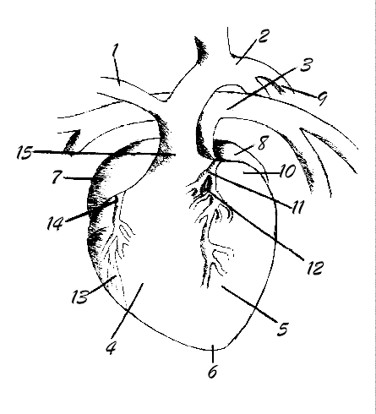
- brachiocephalic artery
- aorta
- pulmonary artery
- right ventricle
- left ventricle
- apex
- right auricle
- left auricle
- ductus arteriosus
- left atrium
- bicuspid valve
- chordae tendinae
- papillary muscle
- tricuspid valve
- semilunar valve

- aorta: large artery that carries blood from the heart to be distributed by branch arteries
- right ventricle: pumps deoxygenated blood out of the heart into the pulmonary arteries to the lungs for gas exchange
- left ventricle: pumps blood out of the heart into the aorta
- left atrium: pumps oxygenated blood into the left ventricle
- papillary muscle: attached to the chordae tendinae in order for the valves to open and close
- tricuspid valve: prevents blood in the right ventricle from returning into the right atrium
- semilunar valve: prevents blood from re entering the ventricles

DIGESTIVE SYSTEM
In the following sections, you will explore the world of the digestive system. This includes both the oral cavity and the abdominal organs.

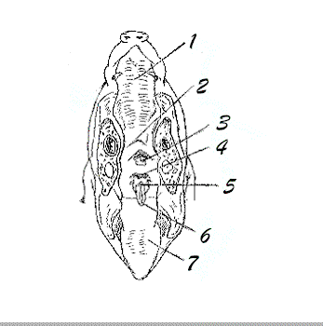
ORAL CAVITY AND PHARYNX
- hard palate
- soft palate
- nasopharynx
- esophagus
- glottis
- epiglottis
- tongue

- hard palate: ridged surface on the roof of the oral cavity
- soft palate: soft part of the oral cavity, located posterior to the hard palate
- nasopharynx: back of the throat
- esophagus: a muscular tube that transports food to the stomach and also serves to aid in mechanical digestion of food
- glottis: opening to the trachea
- epiglottis: flap of tissue that covers the glottis to keep food from entering the trachea

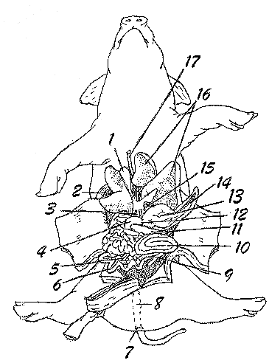
ABDOMINAL ORGANS

- gall bladder
- diaphragm
- bile duct
- duodenum
- mesentery
- small intestine
- anus
- rectum
- cecum
- colon
- pancreas
- pyloric sphincter
- stomach
- spleen
- esophagus
- liver
- umbilical vein

- gall bladder: stores bile that is produced by the liver
- diaphragm: dome-shaped muscle that contracts to draw air into the lungs; most important organ in respiration
- small intestine: secretes digestive enzymes; where most absorption of digested nutrients occurs
- anus: an opening located ventral to the tail where feces is excreted
- rectum: tube that transports undigested food from the large intestine out of the body
- colon: a compact, rounded mass of intestine tightly bound by mesentary
- pancreas: a long, whitish, cauliflower-like organ located dorsal to the stomach; produces digestive enzymes
- pyloric sphincter: a hard ring of smooth muscle; creates a boundary between the stomach and the small intestine
- stomach: produces acid for chemical digestion
- spleen: destroys old red blood cells in an adult
- liver: produces bile
- umbilical veins: carries deoxygenated blood from the fetus to the placenta

REPRODUCTIVE SYSTEM (MALE)
In this section, we will explore the male reproductive system.

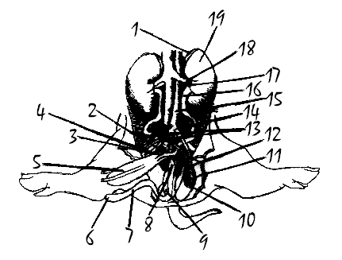
- adrenal gland
- seminal vesicle
- prostate location
- inguinal canal
- urinary bladder
- urogenital opening
- penis
- urethra
- bulbourethral (Cowper's) gland
- epididymis
- testis
- vas deferens
- umbilical arteries
- genital artery
- dorsal aorta
- ureter
- renal artery
- renal vein
- kidney

- urinary bladder: stores urine
- penis: removes urine and semen from the body
- urethra: carries urine out of the bladder; carries semen out of the body
- ureter: transports nitrogenous waste from the kidneys to the urinary bladder
- renal arteries: carry blood to the kidneys for filtration
- renal vein: carries purified blood away from the kidneys
- kidney: filters nitrogenous waste from the blood

- urogenital opening (male): opening to the urogenital sinus

REPRODUCTIVE SYSTEM (FEMALE)
In this section, we will explore the female reproductive system.

- kidney
- genital artery
- ureter
- umbilical arteries
- cervix
- urinary bladder
- urethra
- urogenital opening
- urogenital sinus
- vagina (cut open)
- body of uterus
- uterine horn
- oviduct
- ovary
- renal artery
- renal veins

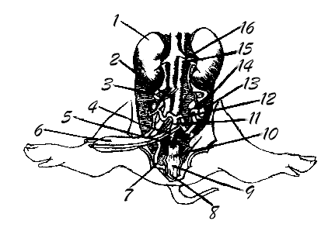

- kidney: filters nitrogenous waste from the blood
- ureter: transports nitrogenous waste from the kidneys to the urinary bladder
- urinary bladder: stores urine
- urethra: carries urine out of the bladder; carries semen out of the body
- urogenital opening (female): opening to the urogenital sinus
- vagina: a canal in a female mammal that leads from the uterus to the external oralface opening into the vestibule between the labia minora
- uterus: an organ in a female mammal that is for containing and usually for nourishing the unborn fetus
- oviduct: a tube that serves exclusively or especially for the passage of eggs from an ovary
- ovary: a female gonad; contains eggs, releases them at maturity, and aids in the production of progesterone and estrogen

SKELETAL SYSTEM

The internal skeletal system is one of the features that make vertebrates unique. The internal skeleton gives support and framework for the body, protection to the internal organs, allows movement, stores minerals, and is the location for blood cell formation in the body

Compare the following structures of human and pigs. Use your textbook and the poster provided during lab practice.

Caudal vertebrae Lumbar vertebrae Thoracic vertebrae
Cervical vertebrae Illium Sacrum
Pubis Scapula Patella
Femur Fibula Tibia
Tarsals Carpals Metatarsals
Metacarpals Phalanges ribs
Humerus Radius Ulna
Sternum Cranium Zygomatic arch
Mandible

